**SQL Hackathon January 2024 80 Queries**

**Team Number: Team1**

**Team Name: Schema Squad**

**Team Members: Kalai, Meenakshi 134, Meenakshi 130, Sharmila, Sudisha**

**Question 1:**

What % of the dataset had clinician reported records vs patient reported?

**Query:**

SELECT

report_source,

COUNT(patient_id) AS patient_count,

ROUND(COUNT(patient_id)*100/ SUM(COUNT(patient_id)) OVER(),2) ||'%' AS patient_percentage

FROM

patient_details

GROUP BY

Report_source;

**Result:**

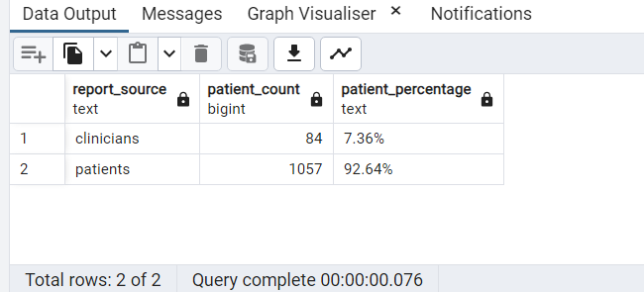

**Question 2:**

Concatenate Patient ID and all symptoms as meaningful words into one string

**Query:**

SELECT

patient_id || ' - ' ||

CASE

WHEN covid19_sympt_chills = 0 AND covid19_sympt_dry_cough = 0 AND covid19_sympt_fatigue = 0

AND covid19_sympt_fever = 0 AND covid19_sympt_loss_smell_taste = 0 AND covid19_sympt_nasal_congestion = 0

AND covid19_sympt_pain = 0 AND covid19_sympt_pneumonia = 0 AND covid19_sympt_shortness_breath = 0

AND covid19_sympt_sore_throat = 0

THEN ' no symptoms'

ELSE

CONCAT(CASE WHEN covid19_sympt_chills = 1 THEN 'Chills, ' END,

CASE WHEN covid19_sympt_dry_cough = 1 THEN 'Dry cough, ' END,

CASE WHEN covid19_sympt_fatigue = 1 THEN 'Fatigue, ' END,

CASE WHEN covid19_sympt_fever = 1 THEN 'Fever, ' END,

CASE WHEN covid19_sympt_loss_smell_taste = 1 THEN 'Loss of smell and taste, ' END,

CASE WHEN covid19_sympt_nasal_congestion = 1 THEN 'Nasal Congestion, ' END,

CASE WHEN covid19_sympt_pain = 1 THEN 'Pain, ' END,

CASE WHEN covid19_sympt_pneumonia = 1 THEN 'Pneumonia, ' END,

CASE WHEN covid19_sympt_shortness_breath = 1 THEN 'Shortness of breath, ' END,

CASE WHEN covid19_sympt_sore_throat = 1 THEN 'Sore throat,' END)

END as patient_symptoms

FROM

Covid_symptoms;

**Result:**

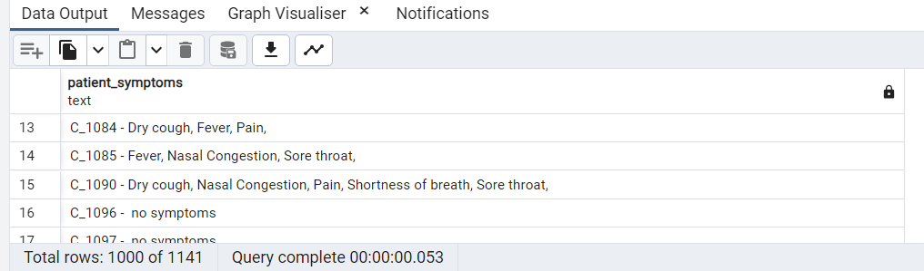

**Question 3:**

What percentage of those in the ICU are smokers?

**Query:**

SELECT

SUM(CASE WHEN cd.covid19_icu_stay = 1

AND pd.smoker = 1 THEN 1 ELSE 0 END)*100/

NULLIF(SUM(CASE WHEN cd.covid19_icu_stay = 1 THEN 1 ELSE 0 END),0)

|| '%' AS percentage_smoker_icu

FROM

patient_details pd

INNER JOIN

covid_details cd

ON

pd.patient_id = cd.patient_id

WHERE

cd.covid19_icu_stay = 1;

**Result:**

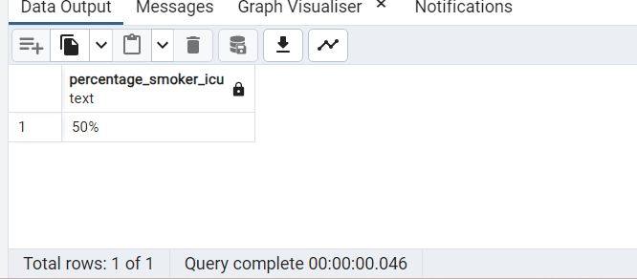

**Question 4:**

Create a crosstab with each type of MS as columns and covid

--diagnosed/not diagnosed as rows and show count of patients in each group.

**Query:**

SELECT

ms_type2,

COUNT(pd.patient_id) AS totalpatients,

SUM(CASE WHEN cd.covid19_confirmed_case = 1 THEN 1 ELSE 0 END) AS "Diagnosed",

SUM(CASE WHEN cd.covid19_confirmed_case = 0 THEN 1 ELSE 0 END) AS "Not Diagnosed"

FROM

patient_details pd

LEFT JOIN

covid_details cd

ON

pd.patient_id = cd.patient_id

GROUP BY

ms_type2;

**Result:**

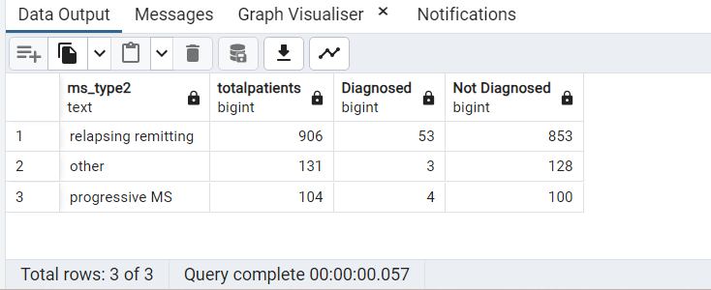

**Question 5:**

How many patients in the dataset are diagnosed with COVID and are on a ventilator?

**Query:**

--Solution 1:

SELECT

COUNT(patient_id) AS patientscount_covid_ventilation

FROM

covid_details

WHERE

covid19_diagnosis = 'confirmed'

AND covid19_ventilation =1;

-- Solution 2:

SELECT

COUNT(patient_id) AS patientscount_covid_ventilation

FROM

covid_details

WHERE

covid19_confirmed_case = 1

AND covid19_ventilation =1;

**Result:**

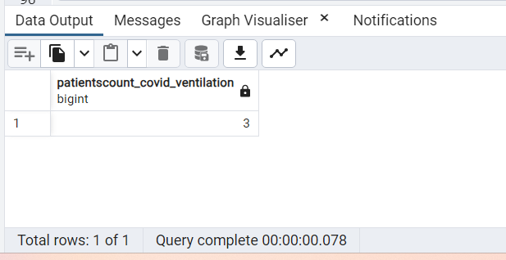

**Question 6:**

Using windows functions show month of onset and the number of hospitalizations in the next month

**Query:**

--Description: COALESCE function replaces null value to 0 (last row of the result )

--Assumption: zero is displayed ,if no of records are found for the next month

--ex.2nd row: for 2020-01 there are no records available for 2020-02 so zero is displayed

SELECT

to_char(date_of_onset, 'YYYY-MM') AS onset_month,

COALESCE (CASE WHEN

LEAD(concat(to_char(date_of_onset, 'YYYY-MM'),'-01'),1)

OVER()::date != concat(to_char(date_of_onset, 'YYYY-MM'),'-01')::date + interval '1 month'

THEN 0

ELSE LEAD(COUNT(patient_id),1) OVER() END,0) as noOfHospitalizationInNextMonth

FROM

covid_details

WHERE

covid19_admission_hospital=1

GROUP BY

to_char(date_of_onset, 'YYYY-MM')

ORDER BY

to_char(date_of_onset, 'YYYY-MM');

**Result:**

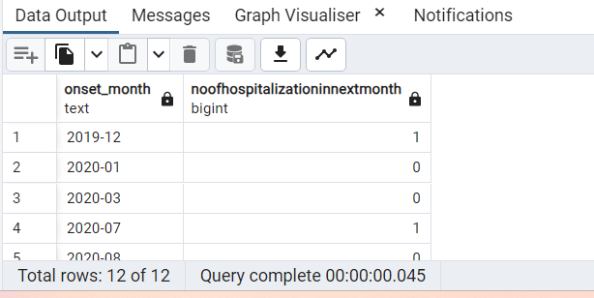

**Question 7:**

How many patients have covid and have reported symptoms of chills?

**Query:**

SELECT

COUNT(cs.patient_id) AS num_patients_with_covid_chills

FROM

covid_details cd

JOIN

covid_symptoms cs

ON

cs.patient_id = cd.patient_id

WHERE

cd.covid19_confirmed_case = 1

AND cs.covid19_sympt_chills = 1;

**Result:**

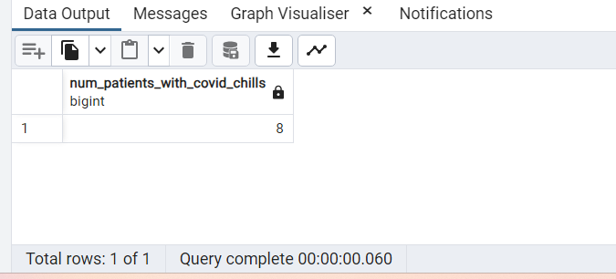

**Question 8:**

Add a column to the patient table which translates age_in_cat to the following values.

--(0: age range <18, 1: age range 18-50,2: age range 51-70,3: age range >71)

**Query:**

-- create a procedure to add column and update the column

CREATE OR REPLACE PROCEDURE catAge_to_HumanAge()

AS

$$

BEGIN

-- Add a new column to the table if it does not exists

ALTER TABLE patient_details ADD COLUMN IF NOT EXISTS human_age varchar(20);

-- Update the new column with the data

UPDATE patient_details

SET human_age = CASE

WHEN age_in_cat=0 THEN '<18'

WHEN age_in_cat=1 THEN '18-50'

WHEN age_in_cat=2 THEN '51-70'

WHEN age_in_cat=3 THEN '>71'

END;

END;

$$

LANGUAGE plpgsql;

-- call the stored procedure

CALL catAge_to_HumanAge();

-- Select to see results

select * from patient_details;

**Result:**

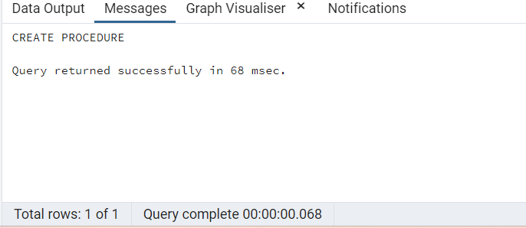

-- call the stored procedure

CALL catAge_to_HumanAge();

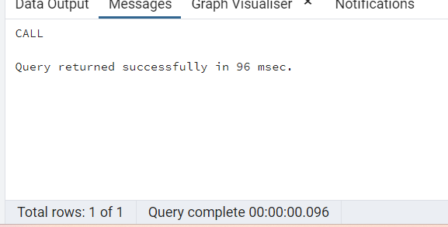

-- Select to see results

select * from patient_details;

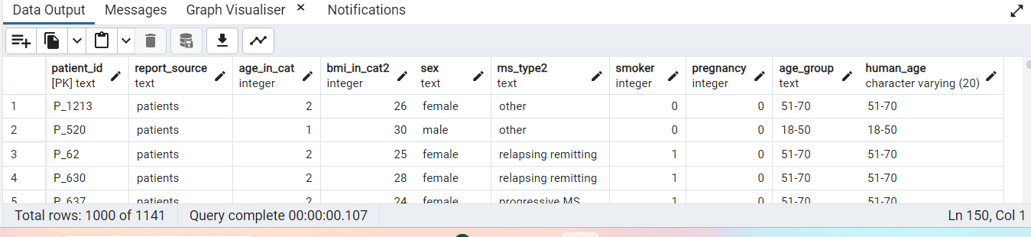

**Question 9:**

Do this within a stored procedure"

How many patients who recovered had no comorbidities?

**Query:**

CREATE OR REPLACE FUNCTION public.get_comorbidities_sum(

patientid text)

RETURNS integer

LANGUAGE 'plpgsql'

COST 100

VOLATILE PARALLEL UNSAFE

AS $BODY$

DECLARE

sum_comorbidities integer;

BEGIN

SELECT SUM(com_cardiovascular_disease + com_chronic_kidney_disease + com_chronic_liver_disease + com_diabetes +

com_hypertension + com_immunodeficiency + com_lung_disease + com_malignancy + com_neurological_neuromuscular)

INTO sum_comorbidities

FROM comorbidities

WHERE patient_ID = patientID;

RETURN sum_comorbidities;

END;

$BODY$;

-- Solution Query

WITH recovered_no_comorbidities

AS

(

SELECT

pd.patient_id,

get_comorbidities_sum(pd.patient_id) AS comorbidities_sum

FROM

patient_details pd

JOIN

covid_details cd

ON

pd.patient_id = cd.patient_id

WHERE

covid19_outcome_recovered = 1

)

SELECT

COUNT(patient_id) as patients_recovered_no_comorbidities

FROM recovered_no_comorbidities

WHERE comorbidities_sum = 0;

**Result:**

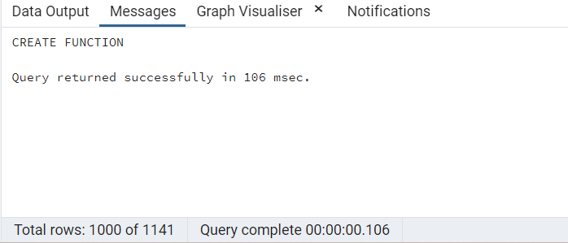

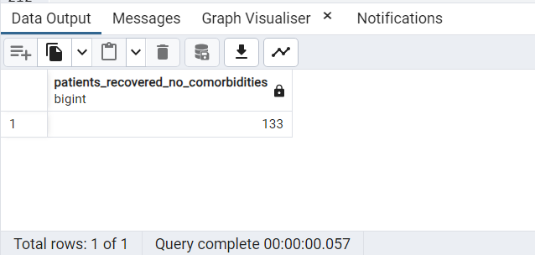

**Question 10:**

What % of overweight patients have COVID?

**Query:**

WITH overweight_covid AS

(

SELECT

cd.covid19_confirmed_case,

to_char((count(pd.patient_id) * 100.0 / sum(count(pd.patient_id)) OVER ()), 'FM90.0" %"') AS Percentage

FROM

patient_details pd

JOIN

covid_details cd

ON

pd.patient_id = cd.patient_id

WHERE

pd.bmi_in_cat2 >= 25

GROUP BY

cd.covid19_confirmed_case

)

SELECT

percentage as percentage_overweight_covid

FROM

overweight_covid

WHERE

covid19_confirmed_case = 1;

**Result:**

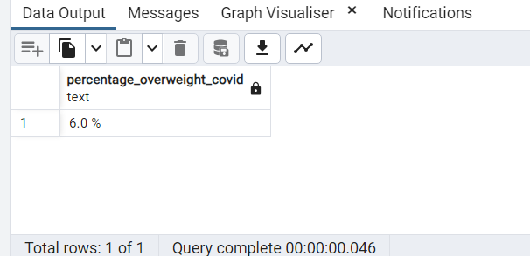

**Question 11:**

What is the correlation between smoking and being on a ventilator?

**Query:**

SELECT

ROUND(CORR(pd.smoker, cd.covid19_ventilation):: numeric,3) AS Correlation

FROM

patient_details pd

JOIN

covid_details cd

ON

pd.patient_id=cd.patient_id;

**Result:**

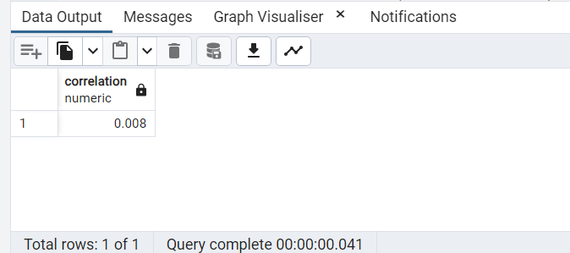

**Question 12:**

Display an array of personal markers:BMI, EDSS, MS Type for every patient. The result should look like this

**Query:**

SELECT

pd.patient_id,

ARRAY[pd.ms_type2, pd.bmi_in_cat2, pm.edss_in_cat2 ]::text[] AS mstype_bmi_edss_marker

FROM

patient_details pd

JOIN

patient_msdetails pm

ON

pd.patient_id = pm.patient_id;

**Result:**

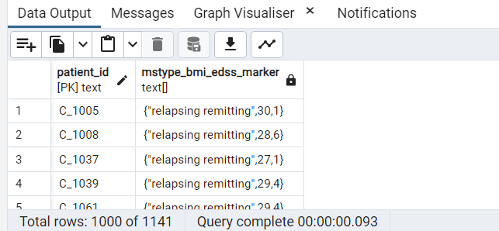

**Question 13:**

What is the Standard deviation, mean and variance from mean in EDSS levels for all patients.

**Query:**

SELECT

STDDEV(edss_in_cat2) AS Standard_dev,

AVG(edss_in_cat2) as Mean,

VARIANCE(edss_in_cat2) as Variance

FROM

patient_msdetails;

**Result:**

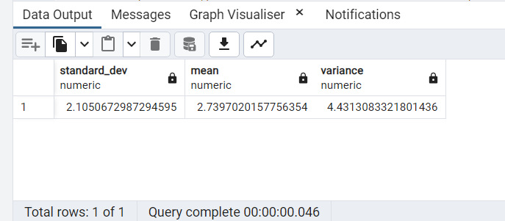

**Question 14:**

Create a materialized view with patient details (for all those with covid) and

assign a COVID severity score to each patient assigning 1 point each for these symptoms.

(cardiovascular_disease,chronic_kidney_disease,chronic_liver_disease,diabetes,hypertension,

immunodeficiency,lung_disease,malignancy,neurological_neuromuscular)

**Query:**

-- DROP MATERIALIZED VIEW IF EXISTS;

DROP MATERIALIZED VIEW view_covidSeverity;

-- Creation of Materialized View

CREATE MATERIALIZED VIEW view_covidSeverity

AS

SELECT cd.patient_id,pd.report_source category,pd.sex,pd.age_group,

(SELECT SUM(com_cardiovascular_disease + com_chronic_kidney_disease + com_chronic_liver_disease + com_diabetes +

com_hypertension + com_immunodeficiency + com_lung_disease + com_malignancy + com_neurological_neuromuscular) AS covid_severity

FROM comorbidities como WHERE cd.patient_id = como.patient_id)

FROM covid_details cd JOIN comorbidities com

ON cd.patient_id = com.patient_id

JOIN patient_details pd

ON cd.patient_id = pd.patient_id

WHERE covid19_confirmed_case = 1

ORDER BY covid_severity DESC

WITH NO DATA;

-- Refresh the view to load the data

REFRESH MATERIALIZED VIEW view_covidSeverity;

-- Select to see the results

SELECT * FROM view_covidSeverity;

**Result:**

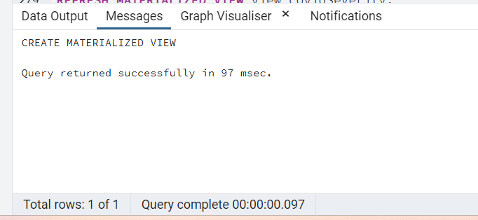

-- Refresh the view to load the data

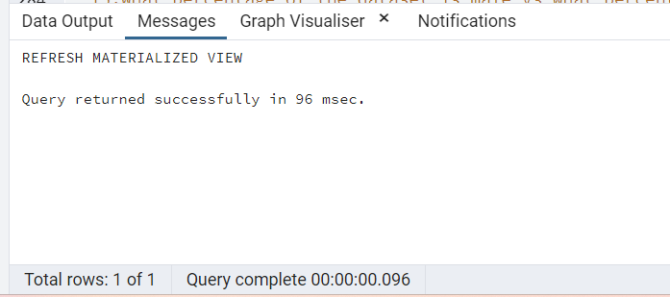

-- Select to see the results

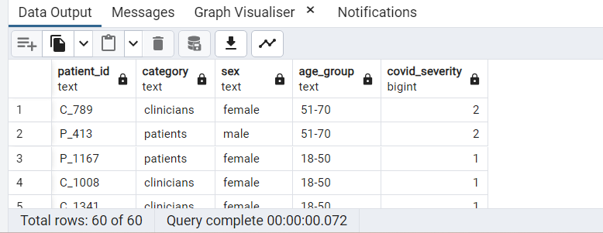

**Question 15:**

What percentage of the dataset is male vs what percentage is female? Calculate without the Use of a subquery or CTE

**Query:**

-- Solution 1

SELECT

ROUND((COUNT(CASE WHEN sex = 'male' THEN 1 END) * 100.0 / COUNT(*)),2) || '%' AS percent_male,

ROUND((COUNT(CASE WHEN sex = 'female' THEN 1 END) * 100.0 / COUNT(*)),2) ||'%' AS percent_female

FROM

patient_details;

-- Solution 2

SELECT

sex, count(patient_id),

to_char((count(patient_id) * 100.0 / sum(count(patient_id)) OVER ()), 'FM90.00" %"') AS Percentage

FROM

patient_details

GROUP BY

Sex;

**Result:**

-- Solution 1

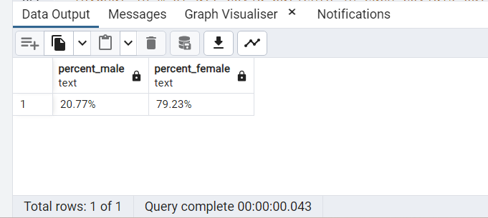

-- Solution 2

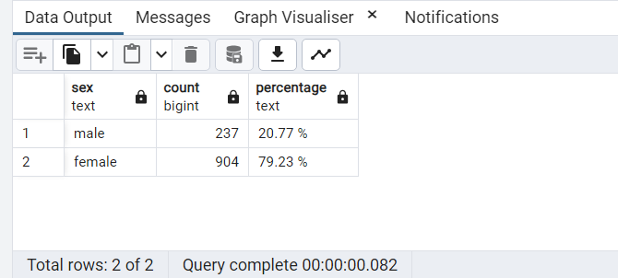

**Question 16:**

Create a function that checks if the patientId entered is a smoker. It should return a true/false answer.

**Query:**

CREATE OR REPLACE FUNCTION patient_issmoker(patientID varchar)

RETURNS boolean

AS

$body$

BEGIN

IF EXISTS(

SELECT patient_id

FROM patient_details

WHERE patient_id = patientID AND smoker = 1

)THEN

RETURN true;

ELSE

RETURN false;

END IF;

END;

$body$ LANGUAGE plpgsql;

--Verify to view the results --

SELECT patient_issmoker('C_1091') AS smoker; -- returns true

SELECT patient_issmoker('P_123') AS smoker; -- returns false

--verify the output ---

SELECT * FROM patient_details WHERE patient_id='C_1091';

SELECT * FROM patient_details WHERE patient_id='P_123';

**Result:**

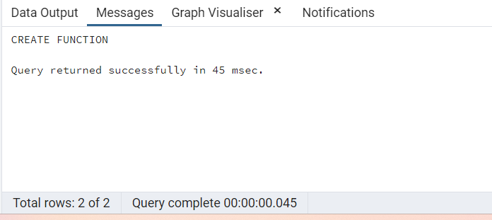

--Verify to view the results --

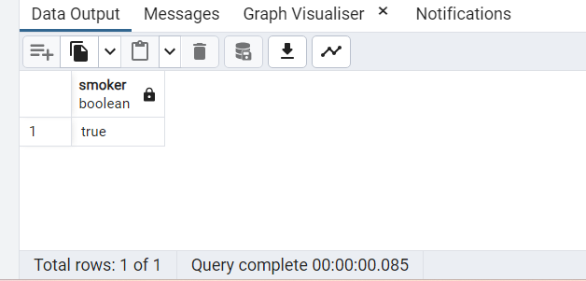

--verify the output ---

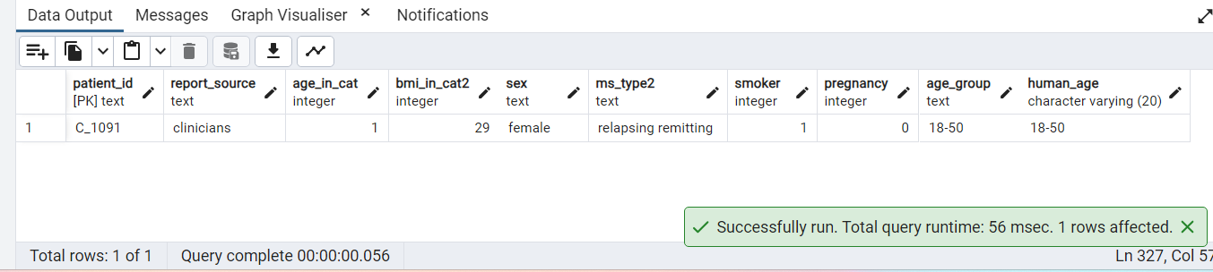

**Question 17:**

How many patients are prescribed drugs have names starting with 'd'

**Query:**

SELECT

COUNT(patient_id) as patientsCount

FROM

patient_msdetails

WHERE

prescribed_drug like 'd%'

**Result:**

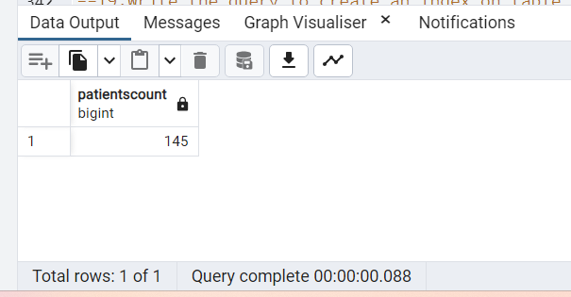

**Question 18:**

What is % of all covid patients in each covid19 outcome levels? Use a windows function without a subquery.

**Query:**

SELECT

covid19_outcome_levels_2,

COUNT(patient_id) as No_of_Patients,

to_char((count(patient_id) * 100.0 / sum(count(patient_id)) OVER ()), 'FM90.0" %"') AS Percentage

FROM

covid_details

GROUP BY

covid19_outcome_levels_2

ORDER BY

covid19_outcome_levels_2 DESC;

**Result:**

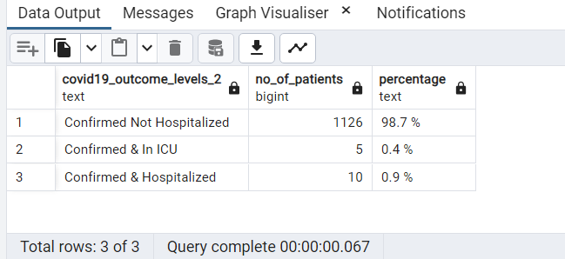

**Question 19:**

Write the query to create an Index on table public.comorbidities by

--selecting a column. Show the index using a query and write a query drop the same index.

**Query:**

-- Query to verify before and after creating index

EXPLAIN ANALYZE

SELECT

pd.patient_id,pd.sex,co.com_hypertension

FROM

Patient_details pd

JOIN

comorbidities co

ON pd.patient_id = co.patient_id

WHERE

sex= 'female' AND co.com_hypertension=1

-- Create index query

CREATE INDEX index_hypertension

ON comorbidities (com_hypertension);

-- Check if index is created

SELECT

indexname,

indexdef

FROM

pg_indexes

WHERE

tablename = 'comorbidities';

**Result:**

-- Query to verify before and after creating index

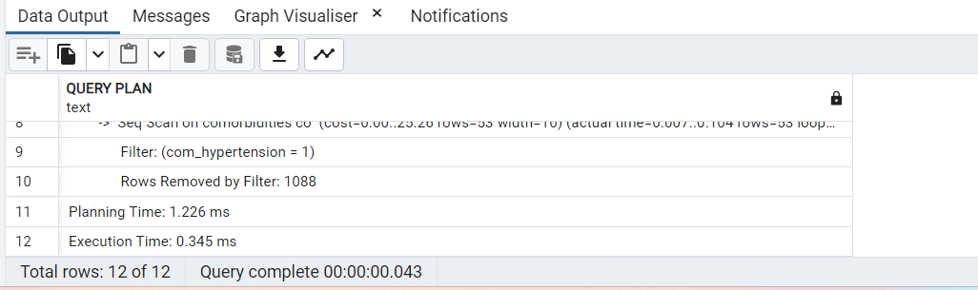

-- Create index query

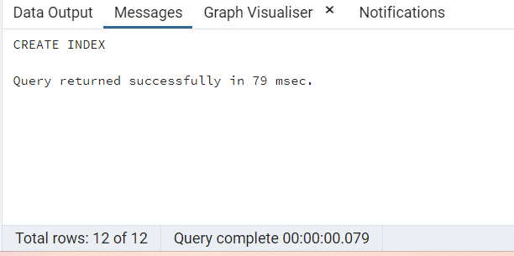

-- Check if index is created

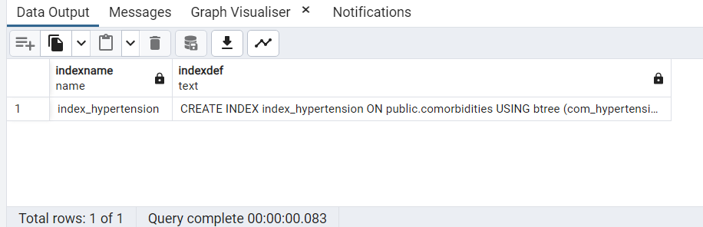

-- Query to verify before and after creating index

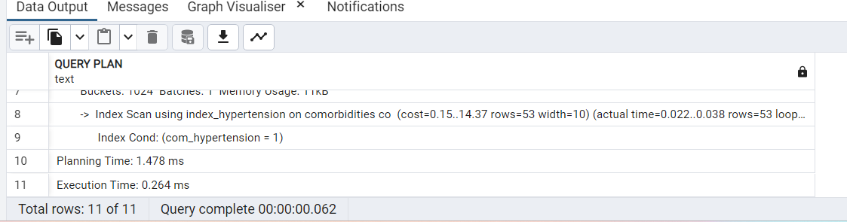

**Question 20:**

What % of total symptoms is Fatigue?

**Query:**

SELECT

covid19_sympt_fatigue,

CASE

WHEN covid19_sympt_fatigue=1 THEN 'Has Fatigue Symptom'

WHEN covid19_sympt_fatigue=0 THEN 'No Fatigue Symptom'

END AS FatigueSymptom,

COUNT(patient_id) as NoofPatients,

to_char((count(patient_id) * 100.0 / sum(count(patient_id)) OVER ()), 'FM90.0" %"') AS Percentage

FROM

covid_symptoms

GROUP BY

covid19_sympt_fatigue

ORDER BY

covid19_sympt_fatigue DESC;

**Result:**

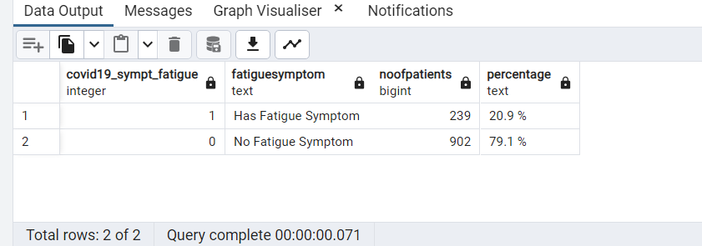

**Question 21:**

List all patients that were admitted between 2020 January and 2020 March

**Query:**

-- Solution 1:

SELECT

*

FROM

public.covid_details

WHERE

date_of_onset BETWEEN '2020-01-01' AND '2020-03-31'

AND covid19_admission_hospital = 1

ORDER BY

patient_id;

-- Solution 2:

SELECT

*

FROM

public.covid_details

WHERE

DATE_PART('MONTH', date_of_onset) IN (1,2,3) AND DATE_PART('YEAR', date_of_onset) = 2020

AND covid19_admission_hospital = 1

ORDER BY

patient_id;

**Result:**

-- Solution 1:

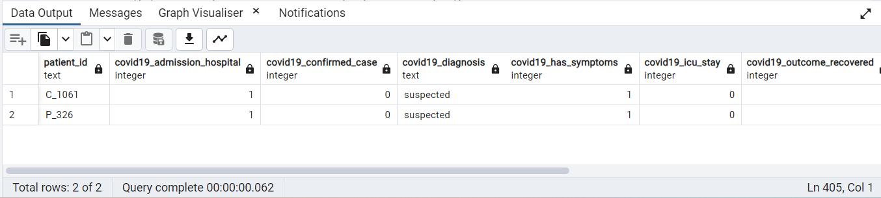

-- Solution 2:

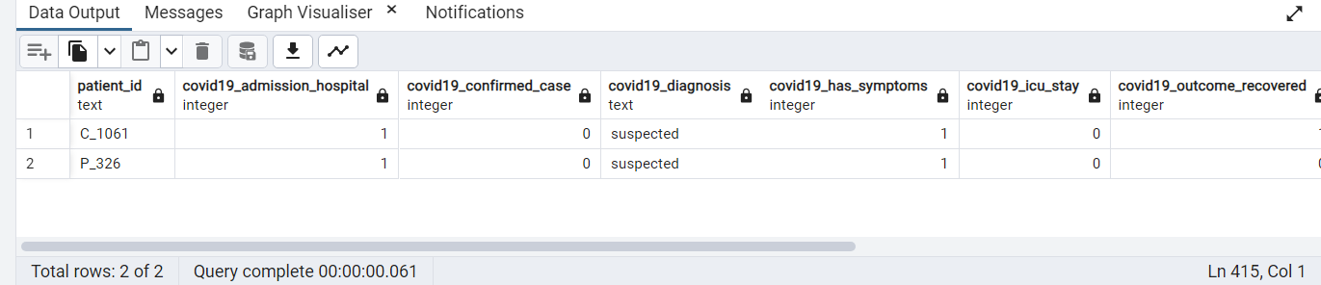

**Question 22:**

On average, how many comorbidities do people with 'progressive_MS' have

**Query:**

SELECT ROUND(AVG(comorbidities_SUM),2) AS Avg_comorbidities

FROM

(SELECT patient_id,sum(com_cardiovascular_disease + com_chronic_kidney_disease + com_chronic_liver_disease + com_diabetes +

com_hypertension + com_immunodeficiency + com_lung_disease + com_malignancy + com_neurological_neuromuscular) AS comorbidities_SUM

FROM comorbidities WHERE patient_id IN (SELECT patient_id FROM patient_details WHERE ms_type2='progressive MS')

GROUP BY patient_id)

**Result:**

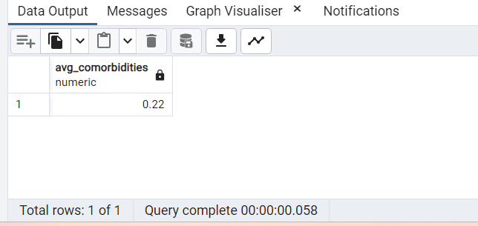

**Question 23:**

Create a view without using any schema or table and check the created view using a select statement.

**Query:**

-- Drop the view if it exists

DROP View IF EXISTS view_NoSchemaTable;

-- Create or replace view with the name "view_NoSchemaTable"

CREATE OR REPLACE VIEW view_NoSchemaTable AS SELECT 'View created without Schema or Table' AS Information;

-- Check the view using select statement

SELECT * FROM view_NoSchemaTable;

**Result:**

-- Create or replace view with the name "view_NoSchemaTable"

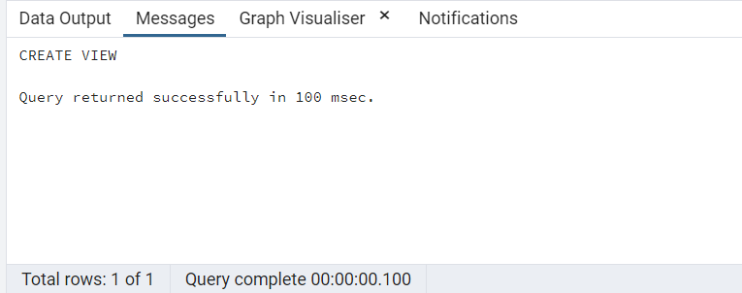

-- Check the view using select statement

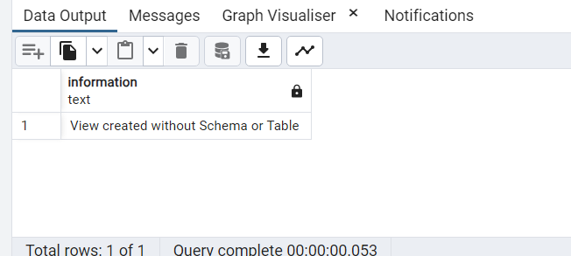

**Question 24:**

Create a crosstab with each type of MS as columns and the medications used as rows

**Query:**

SELECT *

FROM crosstab(

'SELECT pd.patient_id,pd.ms_type2,pm.prescribed_drug

FROM Patient_details pd

JOIN patient_msdetails pm

ON pd.patient_id = pm.patient_id

ORDER BY 1,2',

'SELECT distinct ms_type2 from Patient_details order by 1'

)AS crosstab_mstype (PatientID text,other text, progressive_MS text, relapsing_remitting text);

**Result:**

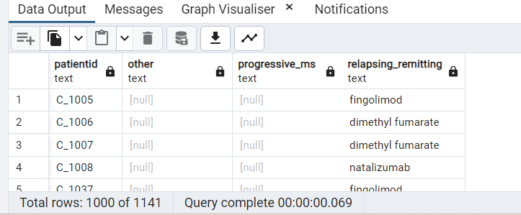

**Question 25:**

"Get the patient's ID who has a max severity score from the materialized view created in Q14 using windows functions.

**Query:**

SELECT

patient_id,covid_severity

FROM

(SELECT patient_id,covid_severity,

RANK() OVER (ORDER BY covid_severity DESC) AS rownum

FROM view_covidSeverity)

WHERE

rownum = 1;

**Result:**

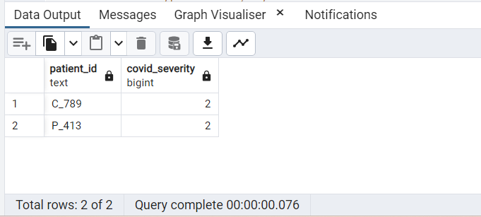

**Question 26:**

Rank the types of MS, by the sum of all comorbidities associated with each one.

**Query:**

-- Considering the highest number as Rank 1 here

-- Solution 1

WITH MS_comorbidities AS

(

SELECT

pd.ms_type2,

(SELECT sum(com_cardiovascular_disease + com_chronic_kidney_disease + com_chronic_liver_disease +

com_diabetes + com_hypertension + com_immunodeficiency + com_lung_disease + com_malignancy +

com_neurological_neuromuscular) AS comorbidities_SUM

FROM comorbidities como

WHERE pd.patient_id = como.patient_id)

FROM

patient_details pd

JOIN

comorbidities como

ON

pd.patient_id = como.patient_id

)

SELECT

ms_type2,SUM(comorbidities_SUM) as comorbiditiesSUM,

RANK () OVER (ORDER BY SUM(comorbidities_SUM) DESC) comorbidities_rank

FROM

MS_comorbidities

GROUP BY

ms_type2;

-- Solution 2:

SELECT

pd.ms_type2,

sum(com_cardiovascular_disease + com_chronic_kidney_disease + com_chronic_liver_disease +

com_diabetes + com_hypertension + com_immunodeficiency + com_lung_disease + com_malignancy +

com_neurological_neuromuscular) AS comorbidities_SUM,

RANK () OVER (ORDER BY sum(com_cardiovascular_disease + com_chronic_kidney_disease + com_chronic_liver_disease +

com_diabetes + com_hypertension + com_immunodeficiency + com_lung_disease + com_malignancy +

com_neurological_neuromuscular) DESC) comorbidities_rank

FROM

patient_details pd

JOIN

comorbidities como

ON

pd.patient_id = como.patient_id

GROUP BY

pd.ms_type2;

**Result:**

-- Solution 1

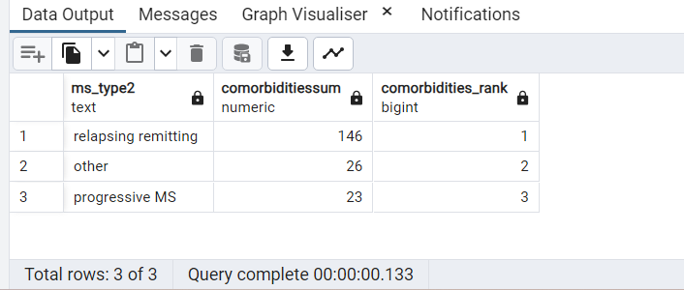

-- Solution 2

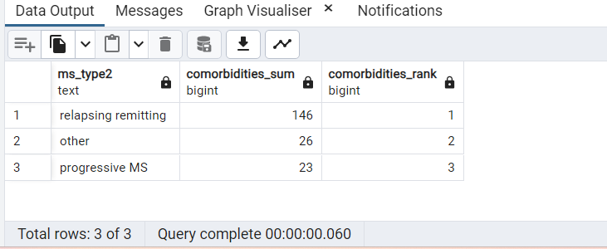

**Question 27:**

What % of patients in the ICU needed ventilation. Calculate and without a subquery or CTE.

**Query:**

SELECT

covid19_ventilation,

CASE

WHEN covid19_ventilation = 0 THEN 'Ventilation Not Required'

WHEN covid19_ventilation = 1 THEN 'Ventilation Required'

END,

count(patient_id) AS No_of_Patients,

to_char((count(patient_id) * 100.0 / sum(count(patient_id)) OVER ()), 'FM90.0" %"') AS Percentage

FROM

covid_details

WHERE

covid19_icu_stay = 1

GROUP BY

covid19_ventilation;

**Result:**

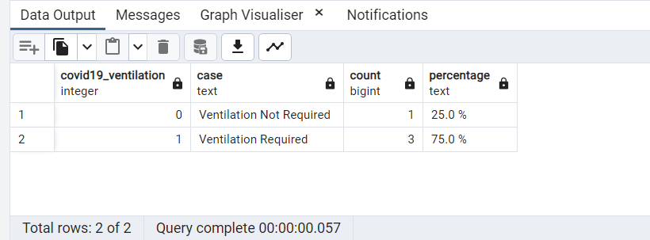

**Question 28:**

Using mean and std_dev create your own 10 Patient_ids and EDSS values that have the same std_dev as the original table

**Query:**

**Result:**

**Question 29:**

calculate the frequency of EDSS and cumulative frequency of EDSS of the patients in the dataset

**Query:**

SELECT

edss_in_cat2 AS EDSS_Value,

COUNT(patient_id) AS EDSS_Frequency,

SUM(COUNT(patient_id)) OVER (ORDER BY edss_in_cat2) AS EDSS_Cumulative

FROM

patient_msdetails

GROUP BY

edss_in_cat2

ORDER BY

edss_in_cat2;

**Result:**

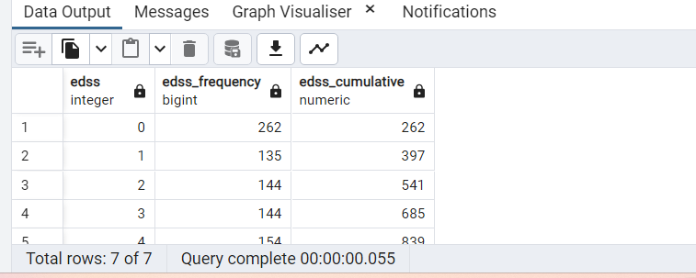

**Question 30:**

How many people who have covid are overweight vs those who are not overweight?

**Query:**

--Considering the universal bmi range and have taken value 25

SELECT

CASE

WHEN pd.bmi_in_cat2 >= 25 THEN 'Overweight'

WHEN pd.bmi_in_cat2 < 25 THEN 'Not Overweight'

END AS BMICategory,

COUNT(pd.bmi_in_cat2) as patientCount

FROM

patient_details pd

JOIN

covid_details cd

ON

pd.patient_id = cd.patient_id

WHERE

covid19_diagnosis = 'confirmed'

GROUP BY

BMICategory;

**Result:**

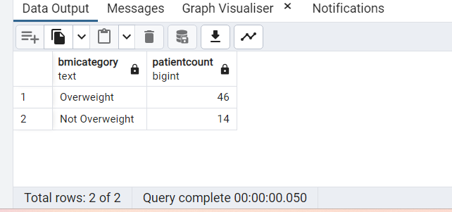

**Question 31:**

What percentage of each MStype are smokers?

**Query:**

SELECT

ms_type2 AS MSType,

count(patient_id) as PatientCount,

to_char((count(patient_id) * 100.0 / sum(count(patient_id)) OVER ()), 'FM90.0" %"') AS Percentage

FROM

patient_details

WHERE

smoker = 1

GROUP BY

ms_type2;

**Result:**

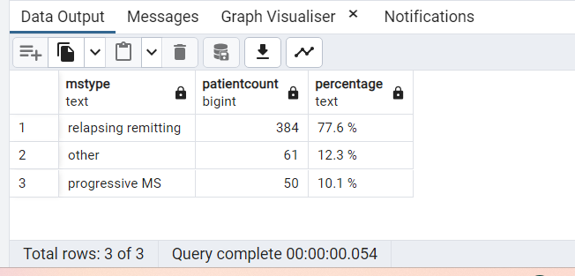

**Question 32:**

Divide avg BMI by avg EDSS and return number of decimals in the result

**Query:**

SELECT

(SELECT AVG(bmi_in_cat2) AS Avg_bmi FROM patient_details) /

(SELECT AVG(edss_in_cat2) AS Avg_edss FROM patient_msdetails) AS Avg_BMI_EDSS,

SCALE((SELECT AVG(bmi_in_cat2) AS Avg_bmi FROM patient_details) /

(SELECT AVG(edss_in_cat2) AS Avg_edss FROM patient_msdetails)) AS No_of_digits;

**Result:**

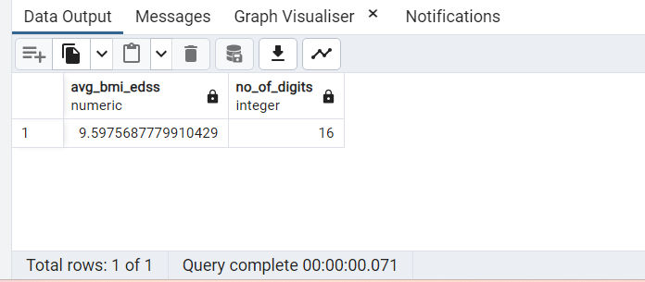

**Question 33:**

List all Patients who are in the youngest age group and did not recover from COVID

**Query:**

--Assumption: not recovered=0, recovered=1

SELECT

patient_id

FROM

patient_details

JOIN

covid_details covid USING (patient_id)

WHERE

covid19_outcome_recovered=0 AND age_in_cat =1

ORDER BY

patient_id;

**Result:**

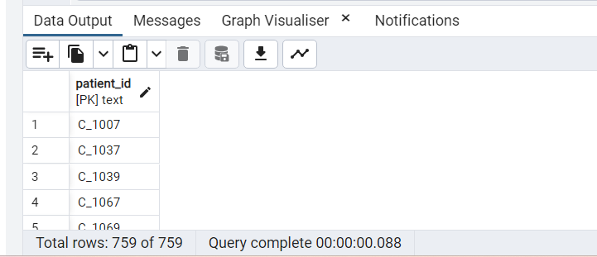

**Question 34:**

Extract the week from the Date Of Onset and show the distribution of week numbers using width bucket function.

**Query:**

-- Description: Created temporary table ‘weeks’ to calculate ‘maxNoOfWeeks’ :

-- To Avoid hard coding

-- To Avoid running subquery in the main query for two times to calculate max no of weeks.

WITH weeks AS (

SELECT MAX(DATE_PART('week', date_of_onset))::int maxNoOfWeeks

FROM covid_details

) --created maxNoOfWeeks

SELECT

WIDTH_BUCKET(DATE_PART('week', date_of_onset), 1,

(SELECT maxNoOfWeeks FROM weeks),

(SELECT maxNoOfWeeks FROM weeks)) AS week_bucket,

COUNT(patient_id) AS No_of_Patients

FROM

covid_details

GROUP BY

week_bucket

ORDER BY

week_bucket;

**Result:**

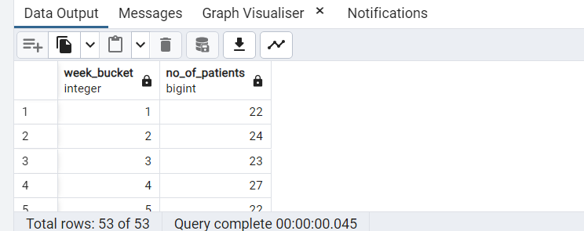

**Question 35:**

How many patients were admitted in the current month of any month

**Query:**

-- Solution 1:

-- Create a function with month_onset as input parameter

CREATE OR REPLACE FUNCTION getPatientCountBasedonMonth(

month_onset int

)

-- returns patient count

RETURNS int

AS $$

DECLARE

No_of_Patients int;

BEGIN

SELECT COUNT(*) INTO No_of_Patients FROM covid_details WHERE

covid19_admission_hospital =1 AND EXTRACT('month' from date_of_onset) = month_onset;

RETURN No_of_Patients;

END;

$$ LANGUAGE plpgsql;

-- execute the select statements to view the results.

SELECT getPatientCountBasedonMonth(1);

SELECT getPatientCountBasedonMonth(EXTRACT('month' FROM CURRENT_DATE)::int);

-- Solution 2:

-- Create a procedure with month_onset as input parameter

CREATE OR REPLACE PROCEDURE pr_get_noOFpaitent_admitted_in_month(monthNo integer)

LANGUAGE plpgsql as

$$

DECLARE

BEGIN

DROP TABLE IF EXISTS MONTH_TEMP;

CREATE TABLE month_temp AS

SELECT TO_CHAR(date_of_onset, 'Month') as month

,count(*) as Patient_Admitted

FROM covid_details

WHERE covid19_admission_hospital =1

AND extract('month' from date_of_onset) = monthNo::integer

GROUP BY TO_CHAR(date_of_onset, 'Month');

IF EXISTS (SELECT * FROM MONTH_TEMP) THEN

RAISE NOTICE using message ='PATIENTS GOT ADMITTED IN THIS MONTH

'||chr(10)||'PLEASE CHECK MONTH_TEMP TABLE, USE'||CHR(10)||

'SELECT * FROM MONTH_TEMP';

ELSE

RAISE NOTICE 'No PATIENTS ADMITTED IN THIS MONTH';

END IF;

EXCEPTION

WHEN OTHERS THEN

RAISE NOTICE 'An error occured: %', SQLERRM;

END; $$

-- execute to see results of currect month of any month

CALL pr_get_noOFpaitent_admitted_in_month(EXTRACT('month' FROM CURRENT_DATE)::int);

-- execute to see result

CALL pr_get_noOFpaitent_admitted_in_month(9); ---not found msg will get displayed

CALL pr_get_noOFpaitent_admitted_in_month(1);

SELECT * FROM month_temp;

**Result:**

-- Solution 1:

-- Create a function with month_onset as input parameter

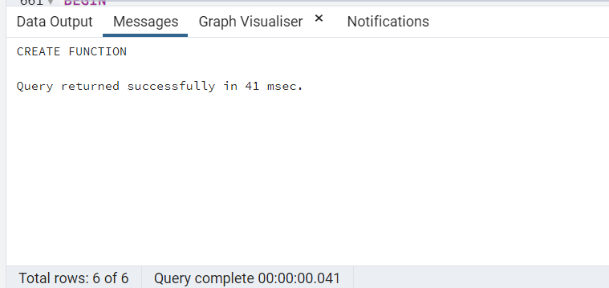

-- execute the select statements to view the results.

SELECT getPatientCountBasedonMonth(1);

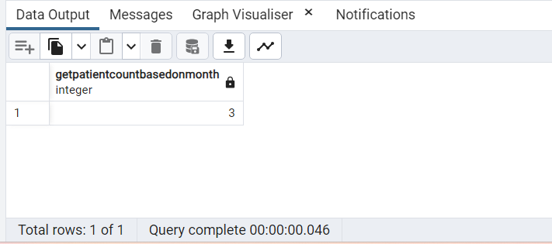

SELECT getPatientCountBasedonMonth(EXTRACT('month' FROM CURRENT_DATE)::int);

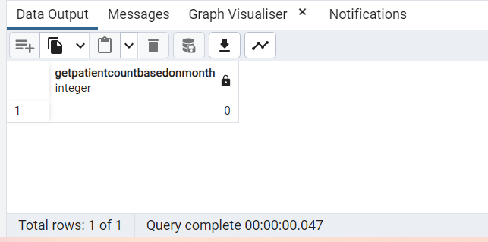

**Question 36:**

Which drug was most used for severe MS. Your answer should consider both frequency and duration of usage of drugs.

**Query:**

--Assumption:severeMS = ‘progressive MS’

SELECT

drug AS drug_most_used_for_severe_MS

FROM (SELECT prescribed_drug,

Row_number() OVER (ORDER BY

COUNT(prescribed_drug),MAX(duration_treatment_cat2)DESC) AS rowNo

FROM patient_details

JOIN patient_msdetails USING (patient_id)

WHERE ms_type2= 'progressive MS'

GROUP BY prescribed_drug ,duration_treatment_cat2

ORDER BY COUNT(prescribed_drug),duration_treatment_cat2 DESC

) AS DATA(drug,rowNo)

WHERE rowNo=1;

**Result:**

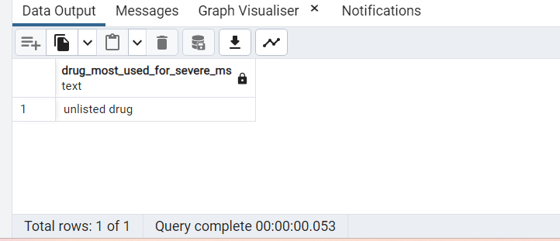

**Question 37:**

How many different types of medication are there in the dataset? Display count of patients against each one.

**Query:**

SELECT

prescribed_drug,

COUNT(patient_id) AS Count_Of_Patients

FROM

patient_msdetails

GROUP BY

prescribed_drug

ORDER BY

COUNT(patient_id) DESC;

**Result:**

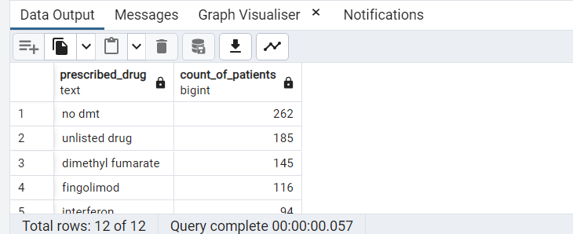

**Question 38:**

Using windows functions show month of onset and the number of hospitalizations in the previous month

**Query:**

--Description: COALESCE function replaces null value to 0 (1st row of the result )

--Assumption: zero is displayed ,if no of records are not found in the previous month

--ex.3rd row: for 2020-03 there are no records available for 2020-02 so zero is displayed

SELECT

to_char(date_of_onset, 'YYYY-MM') AS onset_month,

COALESCE (CASE WHEN

LAG(concat(to_char(date_of_onset, 'YYYY-MM'),'-01'),1)

OVER()::date != concat(to_char(date_of_onset, 'YYYY-MM'),'-01')::date - interval '1 month'

THEN 0

ELSE

LAG(COUNT(patient_id),1) OVER() END,0) AS Hospitalization_PreviousMonth

FROM

covid_details

WHERE

covid19_admission_hospital=1

GROUP BY

to_char(date_of_onset, 'YYYY-MM')

ORDER BY

to_char(date_of_onset, 'YYYY-MM');

**Result:**

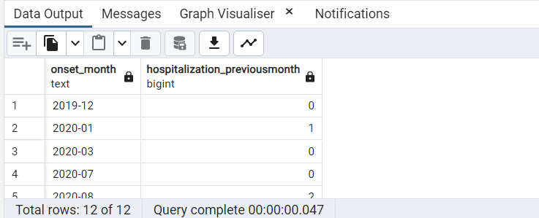

**Question 39:**

List all patients that were admitted during the busiest month in this dataset

**Query:**

-- ASSUMPTION: busiest month = The month and year having maximum records

--in the covid_details table. '2020-05' having maximum records (47) of the dataset.

SELECT

patient_id

FROM

covid_details

WHERE

covid19_admission_hospital= 1

AND to_char(date_of_onset, 'YYYY-MM') IN

(SELECT busiest_month.monthYear FROM (

SELECT COUNT(patient_id) AS cnt,

to_char(date_of_onset, 'YYYY-MM') as monthYear,

RANK() OVER(ORDER BY COUNT(patient_id) DESC) AS rnk

FROM covid_details

GROUP BY to_char(date_of_onset, 'YYYY-MM')

ORDER BY rnk) busiest_month

WHERE rnk =1);

**Result:**

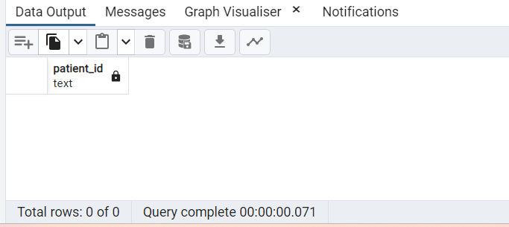

**Question 40:**

Create a function to calculate the total number of people who recovered for every drug entered.

**Query:**

-- Solution 1: Without cursor

CREATE OR REPLACE FUNCTION fn_patientsRecoveredByDrug(drug text)

RETURNS TABLE(no_Of_Patient_Recoverd bigint)

AS $$

BEGIN

RETURN QUERY

SELECT COUNT(c.patient_id) as no_Of_Patient_Recovered

FROM covid_details c

RIGHT JOIN patient_msdetails m using(patient_id)

WHERE covid19_outcome_recovered=1

AND prescribed_drug = drug

GROUP BY prescribed_drug;

EXCEPTION

WHEN OTHERS THEN

RAISE NOTICE 'An error occured: %', SQLERRM;

END

$$ LANGUAGE plpgsql;

--TO EXECUTE FUNCTION

SELECT fn_patientsRecoveredByDrug('glatiramer');

-- Solution 2: With cursor

CREATE OR REPLACE FUNCTION fn_patient_recovered(drug text, patient_cursor refcursor)

RETURNS refcursor

AS $$

BEGIN

RAISE NOTICE USING MESSAGE =

'LOOKING FOR THE PATIENTS RECOVERED USING THIS DRUG '||

drug;

OPEN patient_cursor FOR

SELECT COUNT(c.patient_id) as no_Of_Patient_Recovered

FROM covid_details c

RIGHT JOIN patient_msdetails m using(patient_id)

WHERE covid19_outcome_recovered=1

AND prescribed_drug = drug

GROUP BY prescribed_drug;

RETURN patient_cursor;

END;

$$ LANGUAGE plpgsql;

---TO EXECUTE FUNCTION PLEASE RUN EACH STEP SEPERATELY.

BEGIN

SELECT fn_patient_recovered('latiramer','pcursor');

FETCH ALL FROM pcursor;

END;

BEGIN

SELECT fn_patient_recovered('dimethyl fumarate','pcursor');

FETCH ALL IN pcursor;

END;

**Result:**

-- Solution 1: Without cursor

–create function

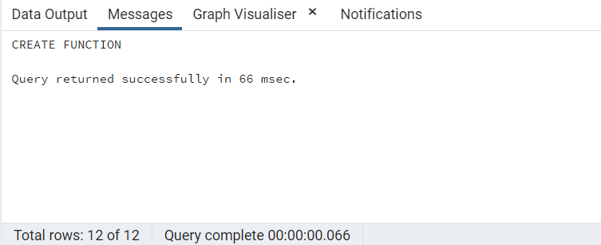

--TO EXECUTE FUNCTION

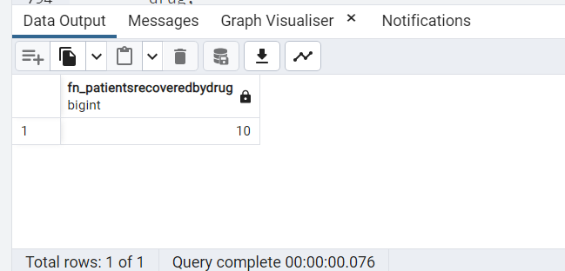

**Question 41:**

How many patients have drug names with length >7 letters?

**Query:**

SELECT

SUM(COUNT(patient_id)) OVER() AS Patients_drugname_length_gt7

FROM

patient_msdetails

WHERE

LENGTH(prescribed_drug)>7;

**Result:**

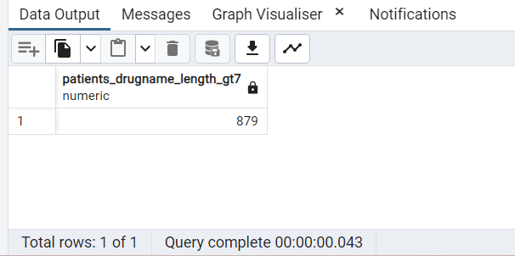

**Question 42:**

Show the moving average of patients every 3 months.

**Query:**

SELECT

move_avg.monYr AS YYYY_MM,move_avg.patients AS patient_count,

round(AVG(move_avg.patients) OVER

(ORDER BY move_avg.monYr ROWS BETWEEN 2 PRECEDING AND CURRENT ROW),2)

AS moving_avg_Of_patients_every3months

FROM

(

SELECT

COUNT(patient_id) AS patients,

to_char(date_of_onset, 'YYYY-MM') AS monYr

FROM

covid_details

GROUP BY

monYr

ORDER BY

monYr

) move_avg;

**Result:**

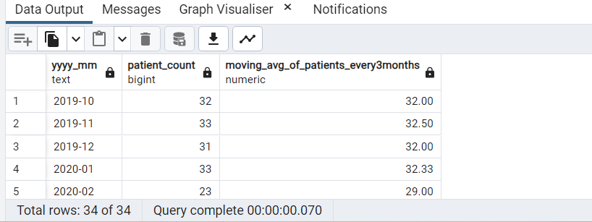

**Question 43:**

What % of those who self isolated showed symptoms vs everyone else?

**Query:**

SELECT

MAX(CASE WHEN isolated.iso=1 THEN isolated.percentage

ELSE null END) AS percentageof_isolated_having_symptoms,

MIN(CASE WHEN isolated.iso = 0 THEN isolated.percentage END) AS percentageof_nonisolated_having_symptoms

FROM

(

SELECT

covid19_self_isolation AS iso,covid19_has_symptoms AS symp,

COUNT(patient_id) as total,

to_char((count(patient_id) * 100.0 / SUM(COUNT(patient_id)) OVER (PARTITION BY covid19_self_isolation)),

'FM90.0" %"') AS Percentage

FROM covid_details

GROUP BY covid19_self_isolation,covid19_has_symptoms

ORDER BY covid19_has_symptoms DESC

)isolated

WHERE

isolated.symp=1;

**Result:**

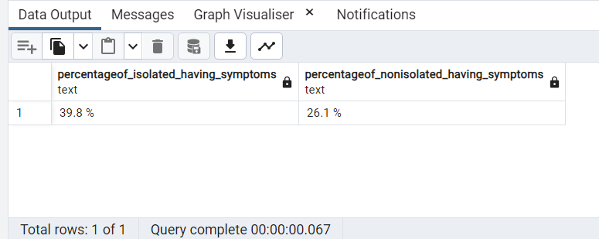

**Question 44:**

Create a trigger to stop patient records from being deleted from the patient details table

**Query:**

--Function

CREATE OR REPLACE FUNCTION stop_delete_patient_detail_tbl()

RETURNS TRIGGER AS $$

DECLARE

BEGIN

RAISE NOTICE 'TG_OP IS %', TG_OP;

IF TG_OP='DELETE' THEN

IF EXISTS (SELECT * FROM patient_details WHERE patient_id = OLD.patient_id) THEN

RAISE EXCEPTION 'Record cannot be deleted';

END IF;

RETURN OLD;

else

RAISE EXCEPTION 'Trigger encountered unknown TG_OP ';

RETURN OLD;

END IF;

END;

$$ LANGUAGE plpgsql;

---created trigger

CREATE OR REPLACE TRIGGER stop_delete_trigger

BEFORE DELETE ON patient_details

FOR EACH ROW

EXECUTE FUNCTION stop_delete_patient_detail_tbl();

---try to delete record from 'covid_detail_temp_tbl'

DELETE FROM patient_details

WHERE PATIENT_ID = 'C_1005';

-- Rollback the transaction for running next query

COMMIT;

**Result:**

--Function

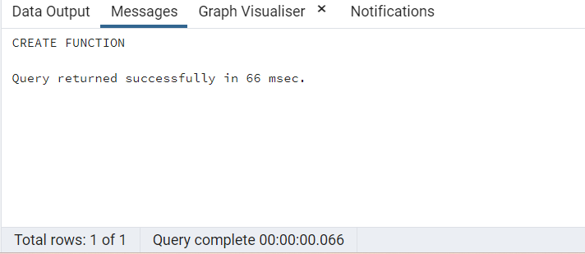

---created trigger

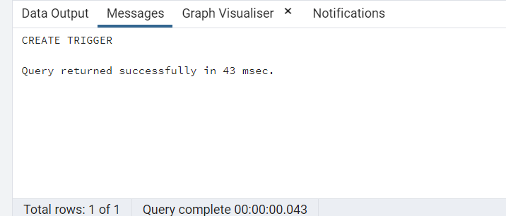

---try to delete record from 'covid_detail_temp_tbl'

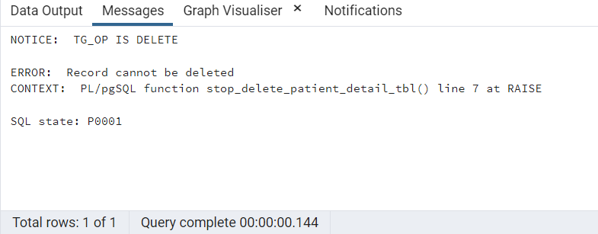

-- Rollback the transaction for running next query

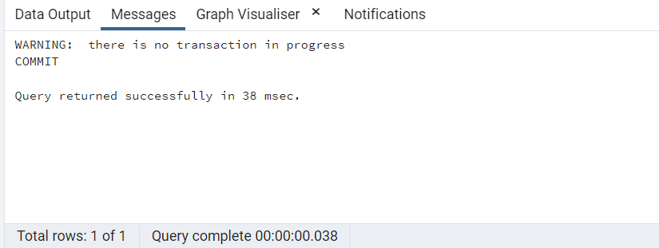

**Question 45:**

Which age-group has the highest count of patients?

**Query:**

-- run commit to rollback the delete trigger transaction before running the next query

COMMIT;

SELECT high_agegroup.age_group

FROM

(SELECT

COUNT(patient_id) AS cnt,

age_group,Row_number() OVER (ORDER BY count(patient_id)DESC) AS rowNo

FROM patient_details

GROUP BY age_group) high_agegroup

WHERE

high_agegroup.rowNo=1;

**Result:**

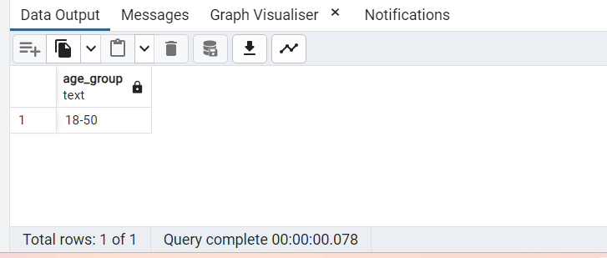

**Question 46:**

Extract only the word fumarate from dimethyl fumarate and show it against the average number of years of treatment

**Query:**

SELECT

substr(prescribed_drug,POSITION('fumarate' IN prescribed_drug),LENGTH(prescribed_drug)) AS drug,

AVG(duration_treatment_cat2)::numeric(10,5) AS avg_years_of_treatment

FROM

patient_msdetails

WHERE

prescribed_drug = 'dimethyl fumarate'

GROUP BY

prescribed_drug;

**Result:**

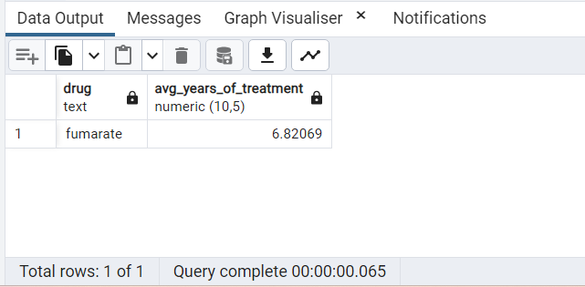

**Question 47:**

Write a query to display all drugs prescribed with Case-Insensitive Replacement of 'Unlisted' to 'Not Found'

**Query:**

SELECT DISTINCT(

(CASE WHEN prescribed_drug ilike '%unlisted%'

THEN 'Not Found' ELSE prescribed_drug END)

) AS prescribed_drug

FROM

patient_msdetails

ORDER BY

prescribed_drug;

**Result:**

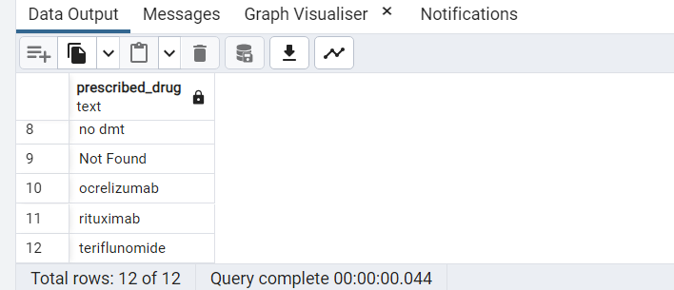

**Question 48:**

Create a table with patientID, BMI and Covid Status using a stored procedure. Add an auto generated sequence as the first column

**Query**:

-- stored procedure to create a table

CREATE OR REPLACE PROCEDURE proc_covid()

LANGUAGE plpgsql

AS $$

BEGIN

CREATE TABLE status_covid(

S_id SERIAL PRIMARY KEY,

PatientID INT,

BMI INT ,

CovidStatus TEXT

);

RAISE NOTICE 'Table Created and Auto Generated Series is added to S_Id';

END;

$$;

-- call the stored procedure

CALL proc_covid();

**Result**:

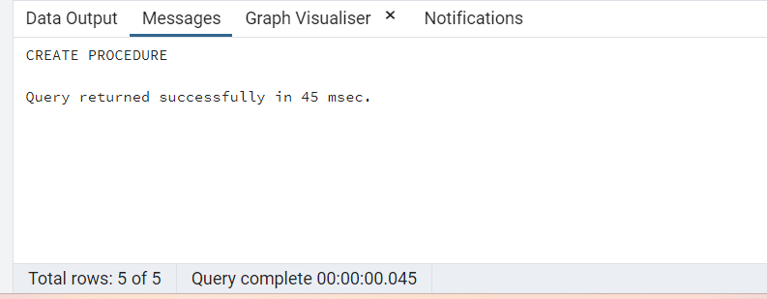

-- call the stored procedure

CALL proc_covid();

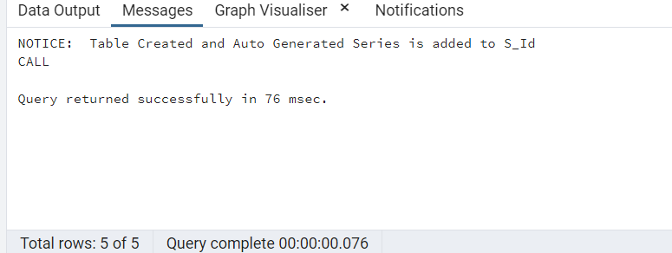

**Question 49:**

List patients where the MS Type ‘ssi’ along with the position where ‘ssi’ appears.

**Query**:

SELECT

patient_id, POSITION('ssi' IN ms_type2) AS position_ssi

FROM

patient_details

WHERE

ms_type2 LIKE '%ssi%';

**Result**:

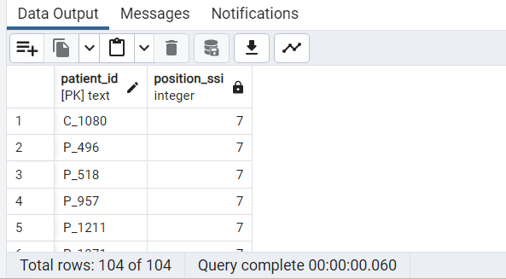

**Question 50:**

Create a child table for the table in Q48 which inherits all the values of the patient table and contains covid symptoms.

--ensure that at least 1 row is inserted into the final table

**Query**:

-- solution to create a child table and insert records

DO $$

BEGIN

IF EXISTS (SELECT 1 FROM information_schema.tables WHERE table_schema = 'public' AND table_name = 'covstatchild') THEN

RAISE NOTICE 'Table already exists , so deleting and creating the new table.';

DROP TABLE covstatchild;

CREATE TABLE covstatchild (

CovidSymptoms INT

) INHERITS (status_covid);

INSERT INTO covstatchild (PatientID, BMI, CovidStatus, CovidSymptoms)

VALUES (6, 12, 'Positive', 1), (8, 19, 'Negative', 0);

ELSE

RAISE NOTICE 'No table found, creating new table';

CREATE TABLE covstatchild (

CovidSymptoms INT

) INHERITS (status_covid);

INSERT INTO covstatchild (PatientID, BMI, CovidStatus, CovidSymptoms)

VALUES (10, 11, 'Positive', 1), (9, 21, 'Negative', 0);

END IF;

END;

$$;

-- select to view results

SELECT * FROM covstatchild;

**Result**:

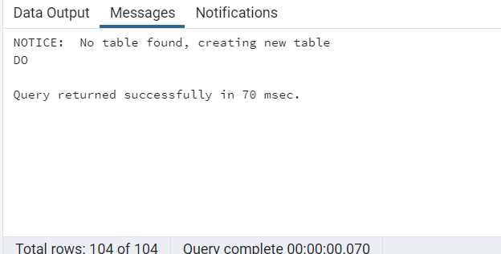

-- select to view results

SELECT * FROM covstatchild;

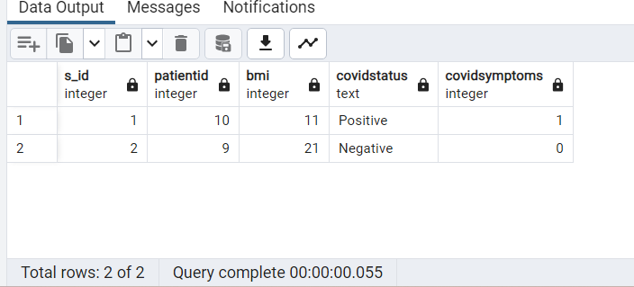

**Question 51:**

List out any 5 patients, add '0' to their first part of the ID so that total characters displayed is 10

**Query:**

WITH PatientsList AS(

SELECT LPAD(patient_id,10,'0') as Patients FROM patient_details

)

SELECT Patients, Length(Patients) as Length_PID FROM PatientsList

ORDER BY RANDOM() LIMIT 5

**Result:**

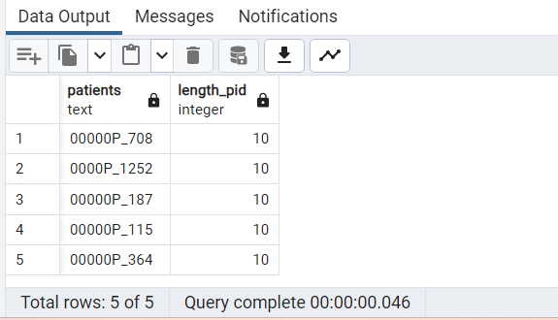

**Question 52:**

Write a trigger after inserting it on the Patient Details table. if the BMI >40, warn for high risk of covid symptoms

**Query:**

-- create a function to return a trigger

CREATE OR REPLACE FUNCTION Pat_Det_trigger_fnc()

RETURNS TRIGGER AS

$$

BEGIN

IF NEW.bmi_in_cat2 > 40 THEN

RAISE NOTICE 'Patient is in high risk of covid symptoms, Inserting data with %bmi_in_cat2', NEW.bmi_in_cat2;

END IF;

RETURN NEW;

END;

$$

LANGUAGE 'plpgsql';

-- create a trigger when a row is inserted

CREATE TRIGGER Pat_Det_Aft_Trigger

AFTER INSERT

ON patient_details

FOR EACH ROW

EXECUTE PROCEDURE Pat_Det_trigger_fnc();

-- insert data to verify the results.

INSERT INTO patient_details Values('P_2424', 'patient', 0, 48, 'female', 'other', 0, 0, '18-50');

INSERT INTO patient_details Values('P_1919', 'patient', 1, 36, 'male', 'other', 0, 0, '18-50');

**Result:**

-- create a function to return a trigger

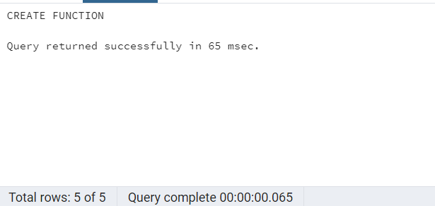

-- create a trigger when a row is inserted

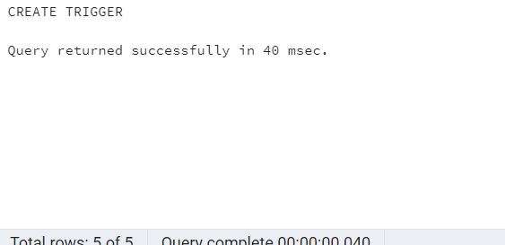

-- insert data to verify the results.

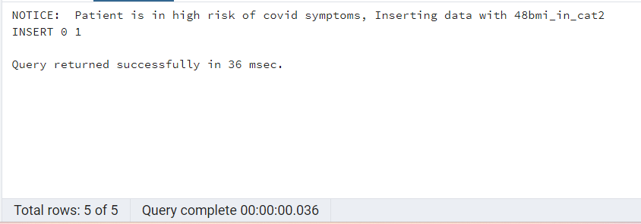

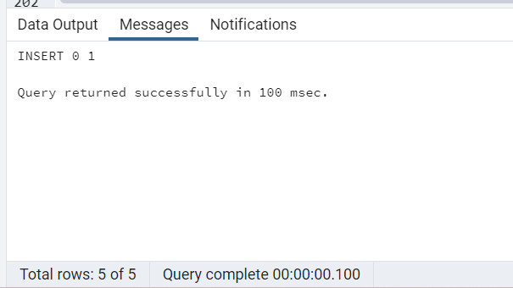

**Question 53:**

Show the MS type of any patient in reverse

**Query:**

-- function to reverse ms_type. Input is patient ID

CREATE OR REPLACE FUNCTION rev_patient (patid text)

RETURNS TABLE (mstype2 text)

LANGUAGE plpgsql

AS $$

BEGIN

RETURN QUERY(

SELECT REVERSE(ms_type2) FROM patient_details

WHERE patient_id = patid

);

END;

$$;

-- select statement to verify the results

SELECT * FROM rev_patient('P_1010');

SELECT * FROM rev_patient('P_123');

**Result:**

-- function to reverse ms_type. Input is patient ID

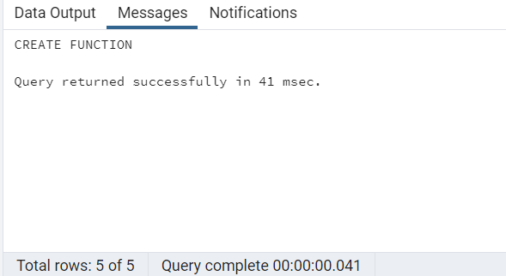

-- select statement to verify the results

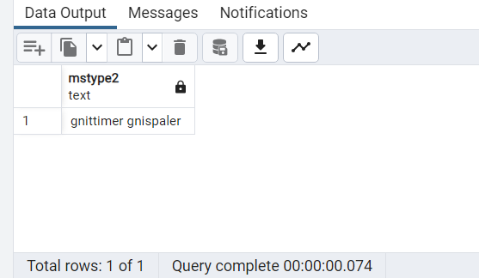

**Question 54:**

Create a pie chart to show the distribution of at least 5 symptoms across patients.

**Query:**

SELECT COUNT(patient_id), Five_Symptoms FROM

(

SELECT patient_id,

CASE

WHEN covid19_sympt_pneumonia = 1 THEN 'Pnemonia'

WHEN covid19_sympt_dry_cough = 1 THEN 'Dry_Cough'

WHEN covid19_sympt_sore_throat = 1 THEN 'Sore Throat'

WHEN covid19_sympt_loss_smell_taste = 1 THEN 'Loss_Smell_Taste'

WHEN covid19_sympt_shortness_breath = 1 THEN 'Shortness of Breath'

ELSE 'Null'

END AS Five_Symptoms FROM covid_symptoms

)

GROUP BY

Five_Symptoms

HAVING

Five_Symptoms <> 'Null';

**Result:**

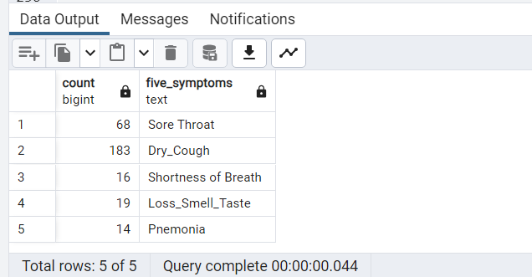

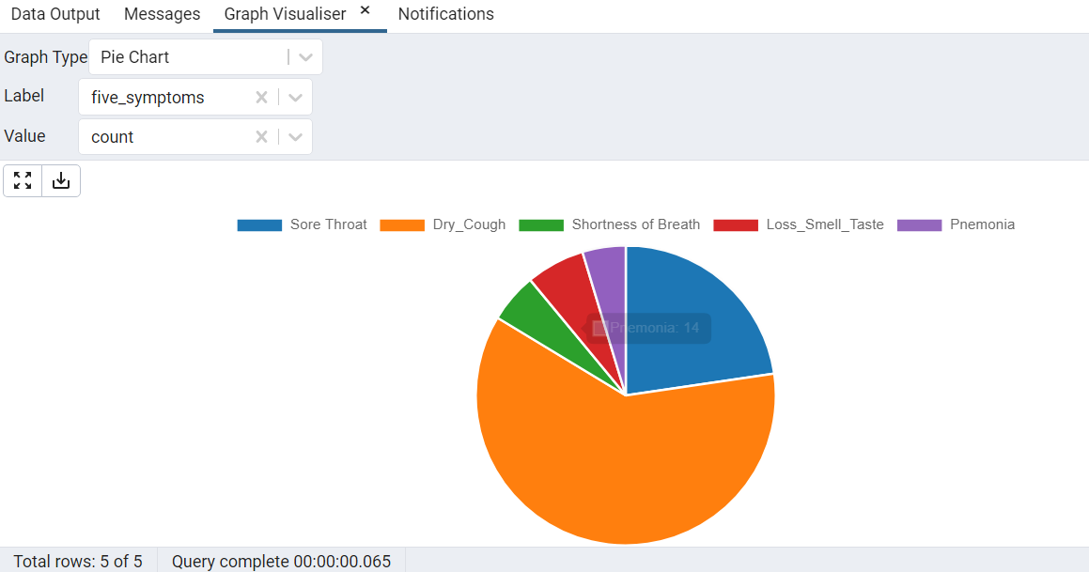

**Question 55:**

How many patients complained of pain as one of the symptoms of COVID.

**Query:**

SELECT

COUNT(patient_id) AS Total_Patients

FROM

covid_symptoms

WHERE

covid19_sympt_pain = 1;

**Result:**

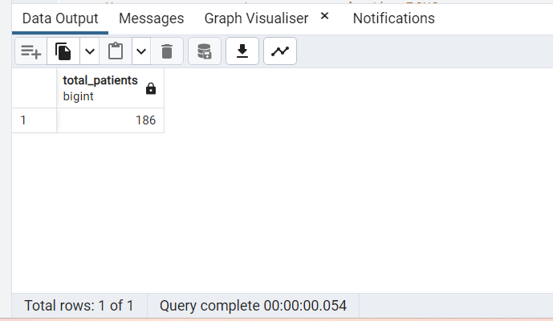

**Question 56:**

Create a view that stores MS Type and any 4 comorbidities

**Query:**

DO $$

BEGIN

IF NOT EXISTS (SELECT 1 FROM information_schema.views WHERE table_name = 'MStype_Com') THEN

-- Create the view here

CREATE OR REPLACE VIEW MStype_Com AS

SELECT ms_type2, com_lung_disease, com_hypertension, com_malignancy,com_diabetes FROM patient_details PD

INNER JOIN comorbidities CO

ON PD.patient_id = CO.patient_id;

RAISE NOTICE 'View created';

ELSE

RAISE NOTICE 'View already exists. Deleting';

DROP VIEW MStype_Com;

CREATE OR REPLACE VIEW MStype_Comorbidities AS

SELECT ms_type2, com_lung_disease, com_hypertension, com_malignancy,com_diabetes from patient_details PD

INNER JOIN comorbidities CO

ON PD.patient_id = CO.patient_id;

RAISE NOTICE 'View created';

END IF;

END $$;

-- Select to see results

SELECT * FROM MStype_Com

**Result:**

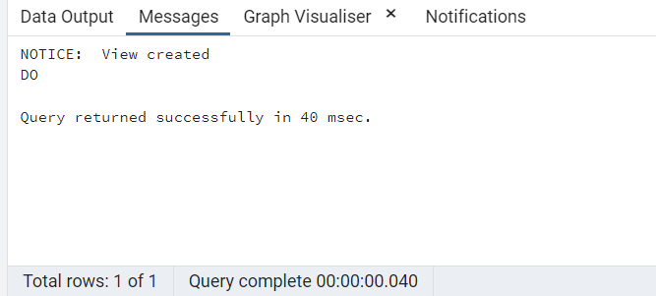

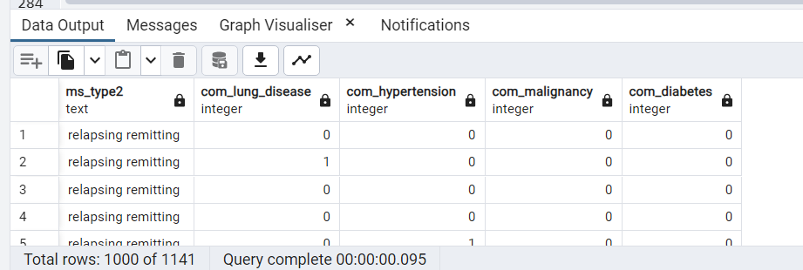

**Question 57:**

How many pregnant women are in the ICU?

**Query:**

SELECT

COUNT(PD.patient_id) as No_of_Patients

FROM

patient_details PD

JOIN

covid_details CD

ON

CD.patient_id = PD.patient_id

WHERE

pregnancy = 1 AND covid19_icu_stay = 1;

**Result:**

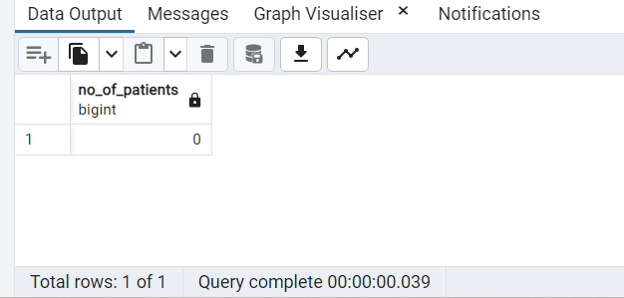

**Question 58:**

Display the Day and Year Of onset in 2 separate columns for the patient who were on no Drugs

**Query:**

SELECT

PM.patient_id, pm.prescribed_drug,

EXTRACT(DAY FROM date_of_onset) AS Day,

EXTRACT(Year FROM date_of_onset) AS Year

FROM

covid_details CD

INNER JOIN

patient_msdetails PM

ON

PM.patient_id=CD.patient_id

WHERE

prescribed_drug = 'no dmt';

**Result:**

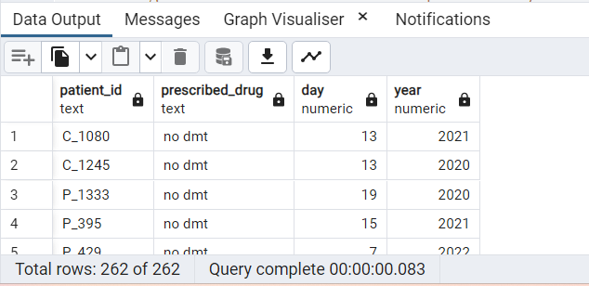

**Question 59:**

What % of the dataset has been confirmed with a diagnosis of covid

**Query:**

SELECT

to_char((Conf_Count * 100.0 / Total_count), 'FM90.00" %"') AS Conf_percent

FROM

(SELECT COUNT(covid19_diagnosis) Conf_Count FROM covid_details WHERE covid19_diagnosis ='confirmed'),

(SELECT COUNT(*) Total_count FROM covid_details);

**Result:**

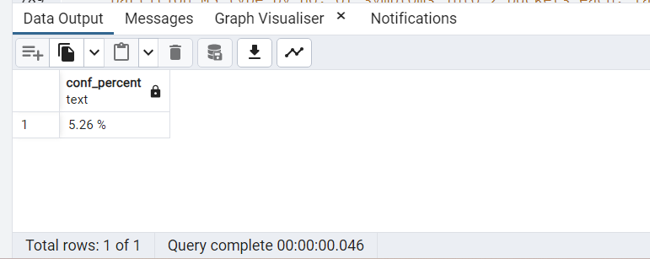

**Question 60:**

Using Windows functions. Divide patients by MS type,

--partition MS_type by no. of symptoms into 2 buckets each, label them as high and low risk. Display avg symptoms in each bucket

**Query:**

WITH MStype_symptoms AS

(SELECT patient_id,

SUM(covid19_sympt_fatigue + covid19_sympt_fever + covid19_sympt_pain + covid19_sympt_sore_throat +

covid19_sympt_chills + covid19_sympt_dry_cough + covid19_sympt_loss_smell_taste +

covid19_sympt_nasal_congestion + covid19_sympt_pneumonia + covid19_sympt_shortness_breath

) AS Total_symp FROM covid_symptoms

GROUP BY patient_id

),

GroupBucket AS (

SELECT patient_id,

CASE

WHEN Total_symp BETWEEN 0 AND 5 THEN 'Low Risk'

WHEN Total_symp BETWEEN 6 AND 10 THEN 'High Risk'

END AS Bucket_Category FROM MStype_symptoms MS

GROUP BY patient_id, Total_symp

)

SELECT

ms_type2, COUNT(MS.patient_id) AS Patient_count, Total_symp, Bucket_Category,

ROUND(AVG(Total_symp) OVER(partition by Bucket_Category),2) AS Avg_symp

FROM MStype_symptoms MS

JOIN GroupBucket B

ON MS.patient_id = B.patient_id

JOIN patient_details PD

ON MS.patient_id = PD.patient_id

GROUP BY ms_type2, Total_symp, Bucket_Category

ORDER BY Total_symp;

**Result:**

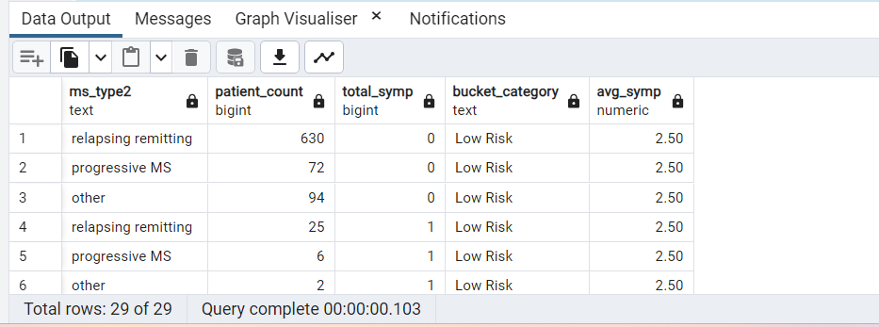

**Question 61:**

Using the ANY function, what is the maximum treatment duration observed among all patients?

**Query:**

SELECT

MAX(duration_treatment_cat2) AS Treatment_duration

FROM

patient_msdetails

WHERE

patient_id = ANY(SELECT patient_id FROM patient_details);

**Result:**

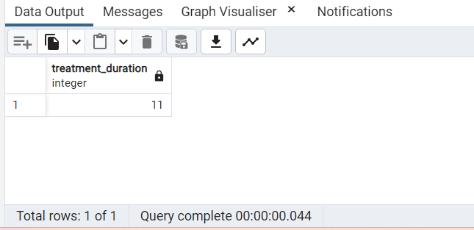

**Question 62:**

Use Case statements to add meaning to the EDSS Score and show number of patients and covid diagnosis per group

**Query:**

SELECT

CASE

WHEN edss_in_cat2 ='0' THEN 'Normal Neuro Examination'

WHEN edss_in_cat2 >'0' AND edss_in_cat2 <='5' THEN 'Fully ambulatory patients'

WHEN edss_in_cat2 ='10' THEN 'MS-related death cases'

ELSE ' With Assistance'

END AS EDSS_Score,

COUNT(cd.patient_id) AS Patient_Count,

COUNT(cd.covid19_diagnosis) AS Covid_diagnosis_Count

FROM

patient_msdetails p

JOIN

covid_details cd

ON cd.patient_id = p.patient_id

GROUP BY

cd.covid19_diagnosis, EDSS_Score

ORDER BY

EDSS_Score;

**Result:**

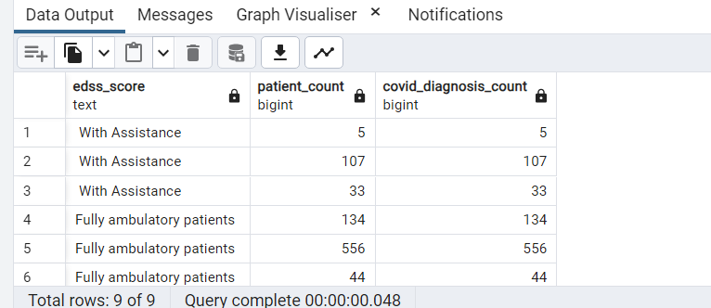

**Question 63:**

Find the average treatment duration for patients and round up to the nearest integer value.

**Query:**

SELECT

ROUND(AVG(duration_treatment_cat2)) AS Total_Treatment_duration

FROM

patient_msdetails;

**Result:**

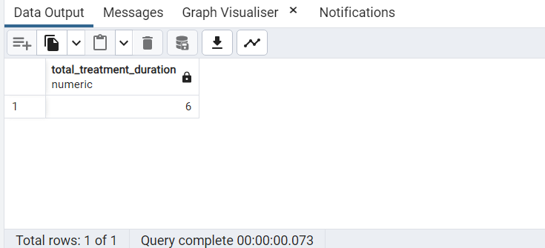

**Question 64:**

Select the top 5 tables in the COVID database by size

**Query:**

SELECT

table_name as CovidDB_TableNames,pg_relation_size(table_schema || '.' || table_name) as CovidDB_Size

FROM

information_schema.tables

WHERE

table_schema NOT IN ('information_schema', 'pg_catalog')

ORDER BY

CovidDB_Size DESC

LIMIT 5;

**Result:**

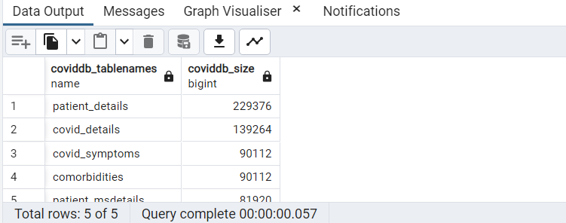

**Question 65:**

Divide EDSS by treatment duration for any 5 patients without using mathematical operators like '/'

**Query:**

-- The DIV() function accepts any positive values, negative values,

-- fractional/floating point values, etc. as arguments and retrieves an integer value

SELECT

patient_ID,edss_in_cat2 AS EDSS,

duration_treatment_cat2 AS treatment_duration,

DIV(edss_in_cat2,duration_treatment_cat2) AS div_EDSS_TreatmentDuration

FROM

patient_msdetails

ORDER BY

RANDOM()

LIMIT 5;

**Result:**

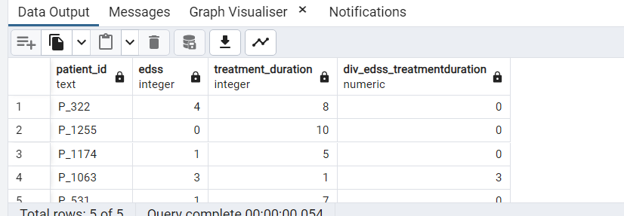

**Question 66:**

Create a trigger on a view from q56.

**Query:**

**Result:**

**Question 67:**

Divide EDSS by treatment duration for any 5 patients without using mathematical operators like '/' and return any remainder

**Query:**

-- MOD() function returns only the remainder after division

SELECT

patient_ID,edss_in_cat2 AS EDSS,

duration_treatment_cat2 AS treatment_duration,

MOD(edss_in_cat2,duration_treatment_cat2) AS remainder_EDSS_TreatmentDuration

FROM

patient_msdetails

ORDER BY

RANDOM()

LIMIT 5;

**Result:**

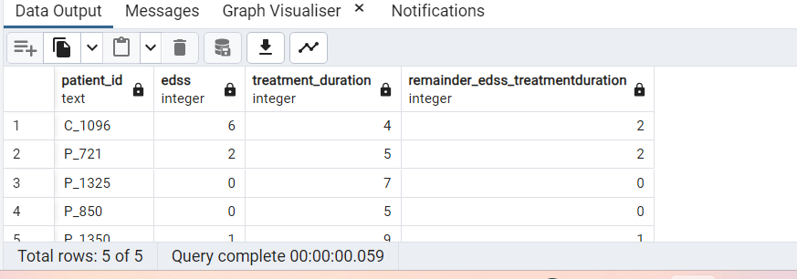

**Question 68:**

Provide the cumulative distribution for MS type based on average being BMI below or above 30.

**Query:**

**Result:**

**Question 69:**

What is the total number of years between the earliest record and the latest

**Query:**

SELECT

EXTRACT(YEAR FROM MAX(date_of_onset)) - EXTRACT(YEAR FROM MIN(date_of_onset)) AS total_years

FROM

covid_details;

**Result:**

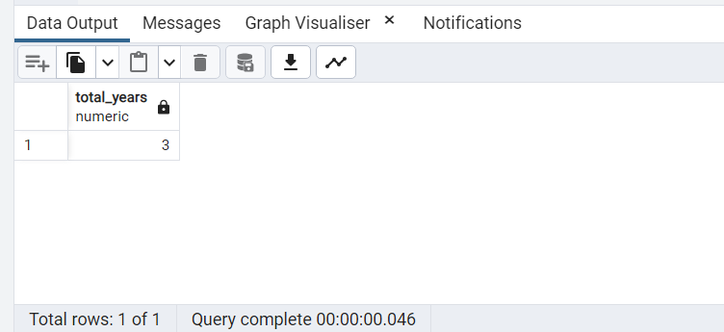

**Question 70:**

What % of those on glucocorticoids have symptoms and what is the most common symptom among this population?

**Query:**

--Functions: ARRAY, LATERAL

SELECT e.percsympt as percentage_on_glucocorticoids_have_symptoms,

d.row AS most_common_symptom FROM (

SELECT SUM(sympArr.elem), sympArr.rowNo

,CASE

WHEN to_char((MAX(SUM(sympArr.elem)) OVER()),'FM90')::integer = SUM(sympArr.elem)

AND sympArr.rowNo = 1 THEN 'covid19_sympt_chills'

WHEN to_char((MAX(SUM(sympArr.elem)) OVER()),'FM90')::integer = SUM(sympArr.elem)

AND sympArr.rowNo = 2 THEN 'covid19_sympt_fatigue'

WHEN to_char((MAX(SUM(sympArr.elem)) OVER()),'FM90')::integer = SUM(sympArr.elem)

AND sympArr.rowNo = 3 THEN 'covid19_sympt_dry_cough'

WHEN to_char((MAX(SUM(sympArr.elem)) OVER()),'FM90')::integer = SUM(sympArr.elem)

AND sympArr.rowNo = 4 THEN 'covid19_sympt_fever'

WHEN to_char((MAX(SUM(sympArr.elem)) OVER()),'FM90')::integer = SUM(sympArr.elem)

AND sympArr.rowNo = 5 THEN 'covid19_sympt_loss_smell_taste'

WHEN to_char((MAX(SUM(sympArr.elem)) OVER()),'FM90')::integer = SUM(sympArr.elem)

AND sympArr.rowNo = 6 THEN 'covid19_sympt_pain'

WHEN to_char((MAX(SUM(sympArr.elem)) OVER()),'FM90')::integer = SUM(sympArr.elem)

AND sympArr.rowNo = 7 THEN 'covid19_sympt_pneumonia'

ELSE 'null' END AS ROW

FROM

-- select s.patient_id,a.arr from (

COVID_DETAILS c

JOIN PATIENT_MSDETAILS USING (PATIENT_ID)

JOIN COVID_SYMPTOMS S USING (PATIENT_ID) --)

,LATERAL (SELECT ARRAY[

covid19_sympt_chills,covid19_sympt_fatigue,

covid19_sympt_dry_cough,covid19_sympt_fever,

covid19_sympt_loss_smell_taste,covid19_sympt_pain,

covid19_sympt_pneumonia] AS arr) a

, UNNEST(a.arr) WITH ORDINALITY sympArr(elem,rowNo)

WHERE DMT_GLUCOCORTICOID =1

AND 1 = ANY(arr)

GROUP BY rowNo

ORDER BY rowNo

)d

, (SELECT COUNT(s.patient_id),covid19_has_symptoms

,to_char((COUNT(patient_id)*100.0/SUM(COUNT(patient_id))

OVER ()), 'FM90.00"%"')AS percsympt

FROM

COVID_DETAILS c

JOIN PATIENT_MSDETAILS USING (PATIENT_ID)

JOIN COVID_SYMPTOMS S USING (PATIENT_ID)

WHERE DMT_GLUCOCORTICOID =1

GROUP BY covid19_has_symptoms) e

WHERE row != 'null'

AND e.covid19_has_symptoms=1

**Result:**

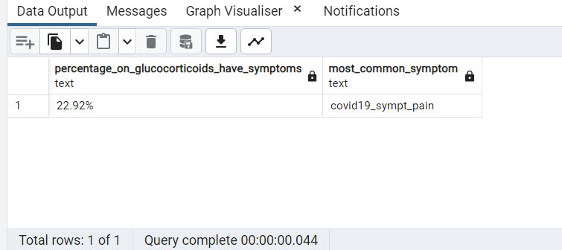

**Question 71:**

Display the patients with the highest BMI.

**Query:**

SELECT *

FROM

patient_details

WHERE

bmi_in_cat2 = (SELECT MAX(bmi_in_cat2) FROM patient_details);

**Result:**

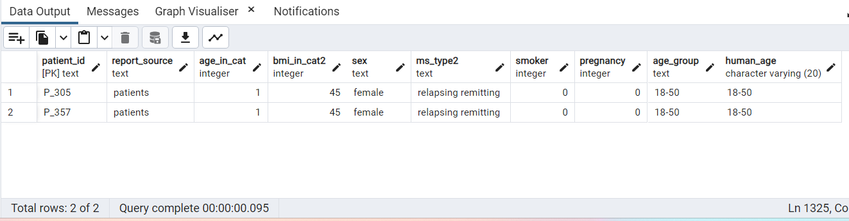

**Question 72:**

Is there a correlation between EDSS and Recovery or Ventilation? Show what correlation exists.

**Query:**

-- correlation between edss and Ventilation

SELECT

round(CORR(pm.edss_in_cat2, cd.covid19_ventilation)::numeric,2) AS correlation_edss_ventilation

FROM

patient_msdetails pm

JOIN

covid_details cd

ON

pm.patient_id = cd.patient_id;

-- correlation between edss and recovery

SELECT

round(CORR(pm.edss_in_cat2, cd.covid19_outcome_recovered)::numeric,2) AS correlation_edss_recovery

FROM

patient_msdetails pm

join

covid_details cd

ON

pm.patient_id = cd.patient_id;

**Result:**

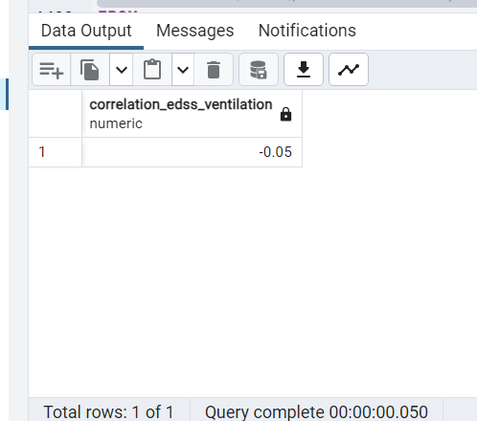

**Question 73:**

How many patients in the dataset have a BMI of 30 or more?

**Query:**

SELECT COUNT(patient_id) FROM patient_details

WHERE bmi_in_cat2 >=30;

**Result:**

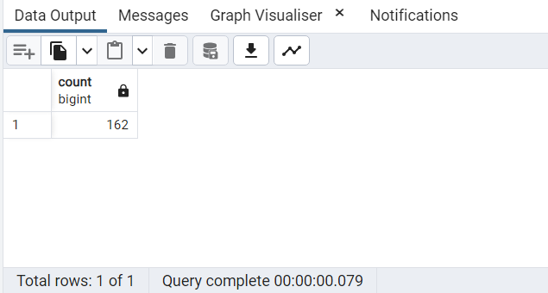

**Question 74:**

How many patients in the ICU had more than 3 comorbidities?

**Query:**

WITH patient_ICU AS

(

SELECT

cd.patient_id,

(SELECT SUM(com_cardiovascular_disease + com_chronic_kidney_disease + com_chronic_liver_disease +

com_diabetes + com_hypertension + com_immunodeficiency + com_lung_disease + com_malignancy +

com_neurological_neuromuscular) AS patient_comorbidities

FROM comorbidities como

WHERE cd.patient_id = como.patient_id)

FROM

covid_details cd

JOIN

comorbidities com

ON

cd.patient_id = com.patient_id

WHERE

covid19_icu_stay = 1

ORDER BY

patient_comorbidities DESC

)

SELECT COUNT(patient_id) as patients_ICU_comorbidities

FROM patient_ICU

WHERE patient_comorbidities > 3

**Result:**

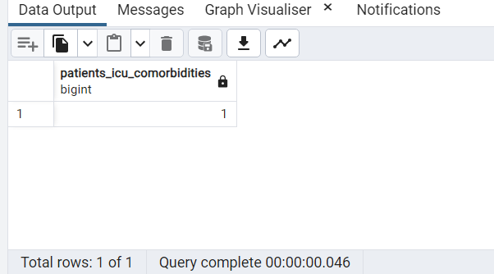

**Question 75:**

Alter table patient_msdetails change the column type of edss_in_cat2 to text and retain all values.

--Reverse the change and re-update it as an integer without losing any values

**Query:**

-- Step 1: Change the column type to text

ALTER TABLE patient_msdetails

ALTER COLUMN edss_in_cat2 TYPE TEXT;

–verifying using select

SELECT * FROM patient_msdetails

-- Step 2: Reverse the column type to integer

ALTER TABLE patient_msdetails

ALTER COLUMN edss_in_cat2 TYPE INTEGER

USING (edss_in_cat2::INTEGER);

–verifying using select

SELECT * FROM patient_msdetails

**Result:**

-- Step 1: Change the column type to text

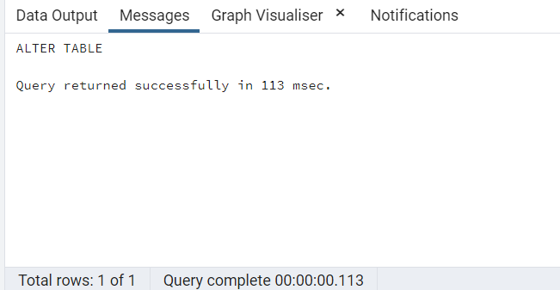

–verifying using select

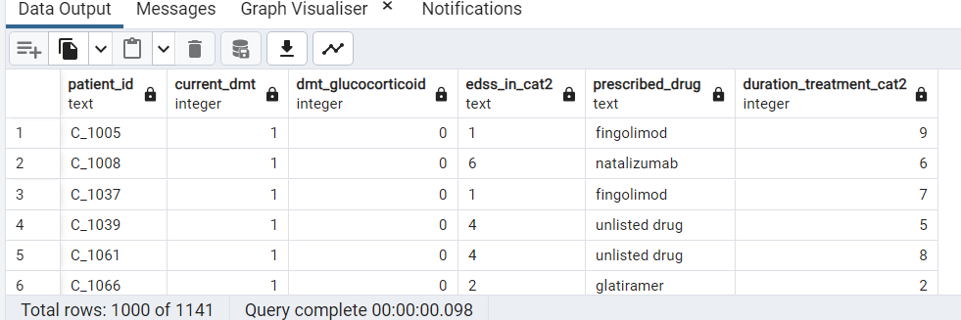

-- Step 2: Reverse the column type to integer

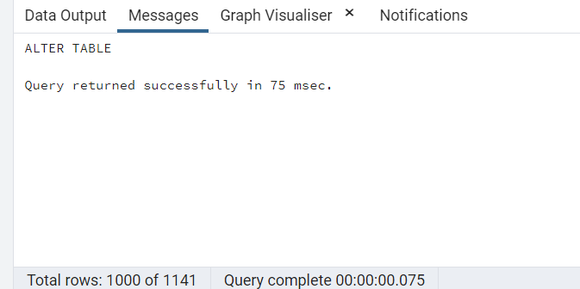

–verifying using select

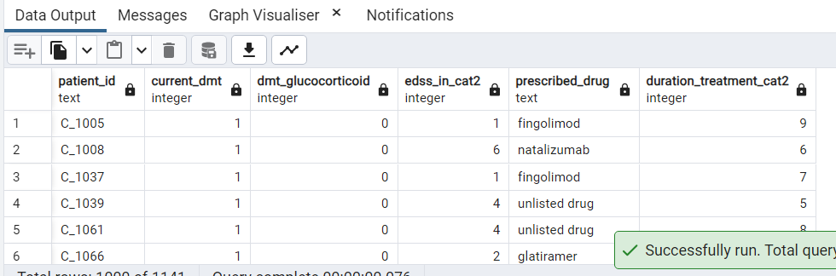

**Question 76:**

Write a query using recursive view(use the given dataset only)

**Query:**

--created recursive view to find patients those are admitted in the hospital

--in the same month (year may differ) for date_of_onset for patient 'C_1005'

CREATE OR REPLACE RECURSIVE VIEW recursive_view (patient,patient1,dt) AS

SELECT patient_id AS patient, 'patient1' AS patient1

,DATE_PART('month',date_of_onset) AS dt

FROM

covid_details

where patient_id = 'C_1005'

UNION ALL

SELECT

c.patient_id AS patient1, recursive_view.patient AS patient

,DATE_PART('month',date_of_onset) AS dt

FROM

covid_details c

INNER JOIN recursive_view ON DATE_PART('month',date_of_onset) = recursive_view.dt

WHERE covid19_admission_hospital=1

–verification using select

SELECT * FROM recursive_view

**Result:**

--created recursive view to find patients those are admitted in the hospital

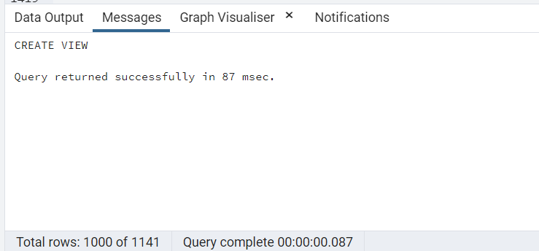

–verification using select

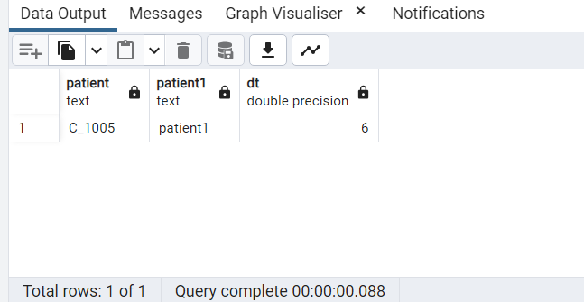

**Question 77:**

What is the 3rd highest BMI of the patients with more than 2 comorbidities? Use windows functions?

**Query:**

WITH patient_comorbidities AS

(

SELECT

pd.patient_id,pd.bmi_in_cat2,

(SELECT sum(com_cardiovascular_disease + com_chronic_kidney_disease + com_chronic_liver_disease

+ com_diabetes + com_hypertension + com_immunodeficiency + com_lung_disease + com_malignancy

+ com_neurological_neuromuscular) AS comorbidities_SUM

FROM comorbidities como WHERE pd.patient_id = como.patient_id)

FROM

patient_details pd

JOIN

comorbidities como

ON

pd.patient_id = como.patient_id

)

SELECT bmi_in_cat2 AS hightest_3rdBMI_having_morethan_2_comorbidties

FROM (SELECT bmi_in_cat2,

DENSE_RANK() OVER (ORDER BY bmi_in_cat2 DESC) AS denserank

FROM patient_comorbidities WHERE comorbidities_SUM > 2)

WHERE denserank = 3;

**Result:**

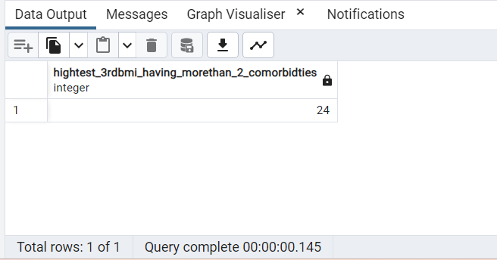

**Question 78:**

Update the table patient_msdetails. Set drugs prescribed to be Sentence case, query the results of the updated table without writing a second query

**Query:**

UPDATE

patient_msdetails

SET

prescribed_drug = INITCAP(prescribed_drug)

RETURNING *;

**Result:**

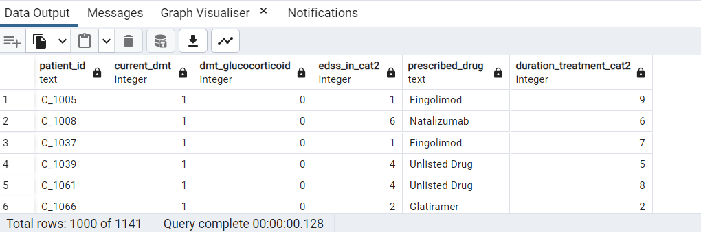

**Question 79:**

Use the materialized view in Q14. to show every patients details in one single line using a JSON function

**Query:**

-- Query to convert all rows into one single line

SELECT

array_to_json(ARRAY_AGG(row_to_json(tablerow)))

FROM (

SELECT patient_id,category,sex,age_group,covid_severity

FROM view_covidSeverity

) tablerow

**Result:**

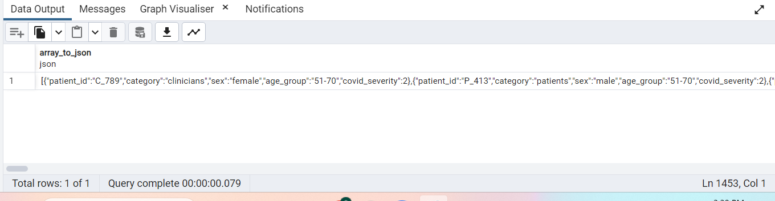

**Question 80:**

Create a stored procedure that adds a column to table Covid Details.

--The column should just be the Year extracted from Date Onset

**Query:**

-- Drop the stored procedure "addcolumn_updateyear" if exists

DROP PROCEDURE IF EXISTS addcolumn_updateyear;

-- Drop the column "onset_year" from the table covid_details if exists

ALTER TABLE covid_details

DROP COLUMN onset_year;

-- Stored Procedure to add a new column and populate the values into that column

CREATE OR REPLACE PROCEDURE addcolumn_updateyear(OUT Infomessage text)

LANGUAGE plpgsql

AS $$

BEGIN

-- Add a new column with the name "onset_year" to covid_details table

ALTER TABLE covid_details

ADD COLUMN onset_year INT;

-- Extract the year from "date_of_onset" column and updates the value to "onset_year" column

UPDATE covid_details

SET onset_year = EXTRACT(YEAR FROM date_of_onset);

SELECT 'Updated Successfully' INTO Infomessage;

END; $$

-- Call to the stored procedure - returns a message after the execution is sucessful.

call addcolumn_updateyear(NULL);

-- Select query to verify the results

SELECT patient_id,date_of_onset,onset_year FROM covid_details;

**Result:**

-- Stored Procedure to add a new column and populate the values into that column

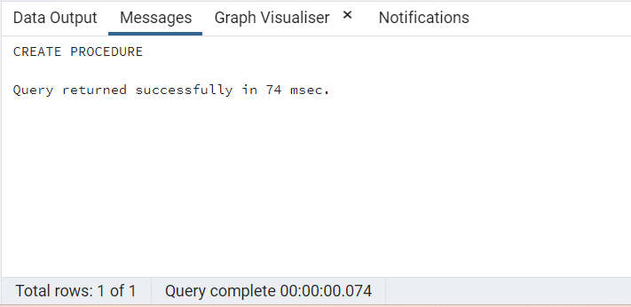

-- Call to the stored procedure - returns a message after the execution is sucessful.

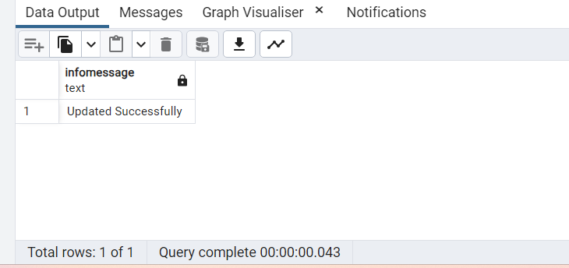

-- Select query to verify the results

